








Carry out vehicle maintenance or minor repairs
D2.TTO.CL4.02
Trainee Manual

Carry out vehicle maintenance or minor repairs
D2.TTO.CL4.02
Trainee Manual





Project Base
William Angliss Institute of TAFE
555 La Trobe Street
Melbourne 3000 Victoria
Telephone: | (03) 9606 2111
Facsimile: | (03) 9670 1330
Acknowledgements
Project Director: | Wayne Crosbie
Project Manager | Jim Irwin
Chief Writer: | Alan Hickman
Subject Writer: | Alan Hickman
Editor: | Jim Irwin
DTP/Production: | Daniel Chee, Mai Vu, Cindy Curran

The Association of Southeast Asian Nations (ASEAN) was established on 8 August 1967. The Member States of the Association are Brunei Darussalam, Cambodia, Indonesia, Lao PDR, Malaysia, Myanmar, Philippines, Singapore, Thailand and Viet Nam.
The ASEAN Secretariat is based in Jakarta, Indonesia.
General Information on ASEAN appears online at the ASEAN Website: www.asean.org.
All text is produced by William Angliss Institute of TAFE for the ASEAN Project on “Toolbox Development for Tourism Labour Divisions for Travel Agencies and Tour Operations”.
This publication is supported by the Australian Government’s aid program through the ASEAN-Australia Development Cooperation Program Phase II (AADCP II).
Copyright: Association of Southeast Asian Nations (ASEAN) 2015.
All rights reserved.
Disclaimer
Every effort has been made to ensure that this publication is free from errors or omissions. However, you should conduct your own enquiries and seek professional advice before relying on any fact, statement or matter contained in this book. The ASEAN Secretariat and William Angliss Institute of TAFE are not responsible for any injury, loss or damage as a result of material included or omitted from this course. Information in this module is current at the time of publication. Time of publication is indicated in the date stamp at the bottom of each page.
Some images appearing in this resource have been purchased from stock photography suppliers Shutterstock and iStockphoto and other third party copyright owners and as such are non-transferable and non-exclusive. Clip arts, font images and illustrations used are from the Microsoft Office Clip Art and Media Library. Some images have been provided by and are the property of William Angliss Institute.
Additional images have been sourced from Flickr and SXC and are used under Creative Commons licence: http://creativecommons.org/licenses/by/2.0/deed.en

File name: TM_Carry_out_vehicle_maintenance_minor_repairs_150514





Table of contents
Introduction to trainee manual 1
Unit descriptor 3
Assessment matrix 5
Glossary 7
Element 1: Provide scheduled service to vehicles 9
Element 2: Diagnose minor vehicle faults 67
Element 3: Undertake minor repairs to vehicles 73
Element 4: Complete documentation 97
Presentation of written work 105
Recommended reading 107
Trainee evaluation sheet 109
Trainee self-assessment checklist 111

Introduction to trainee manual

To the Trainee
Congratulations on joining this course. This Trainee Manual is one part of a ‘toolbox’ which is a resource provided to trainees, trainers and assessors to help you become competent in various areas of your work.
The ‘toolbox’ consists of three elements:
- A Trainee Manual for you to read and study at home or in class
- A Trainer Guide with Power Point slides to help your Trainer explain the content of the training material and provide class activities to help with practice
- An Assessment Manual which provides your Assessor with oral and written questions and other assessment tasks to establish whether or not you have achieved competency.
The first thing you may notice is that this training program and the information you find in the Trainee Manual seems different to the textbooks you have used previously. This is because the method of instruction and examination is different. The method used is called Competency based training (CBT) and Competency based assessment (CBA). CBT and CBA is the training and assessment system chosen by ASEAN (Association of South-East Asian Nations) to train people to work in the tourism and hospitality industry throughout all the ASEAN member states.
What is the CBT and CBA system and why has it been adopted by ASEAN?
CBT is a way of training that concentrates on what a worker can do or is required to do at work. The aim is of the training is to enable trainees to perform tasks and duties at a standard expected by employers. CBT seeks to develop the skills, knowledge and attitudes (or recognise the ones the trainee already possesses) to achieve the required competency standard. ASEAN has adopted the CBT/CBA training system as it is able to produce the type of worker that industry is looking for and this therefore increases trainees’ chances of obtaining employment.
CBA involves collecting evidence and making a judgement of the extent to which a worker can perform his/her duties at the required competency standard. Where a trainee can already demonstrate a degree of competency, either due to prior training or work experience, a process of ‘Recognition of Prior Learning’ (RPL) is available to trainees to recognise this. Please speak to your trainer about RPL if you think this applies to you.
What is a competency standard?
Competency standards are descriptions of the skills and knowledge required to perform a task or activity at the level of a required standard.
242 competency standards for the tourism and hospitality industries throughout the ASEAN region have been developed to cover all the knowledge, skills and attitudes required to work in the following occupational areas:
- Housekeeping
- Food Production
- Food and Beverage Service
- Front Office
- Travel Agencies
- Tour Operations.
All of these competency standards are available for you to look at. In fact you will find a summary of each one at the beginning of each Trainee Manual under the heading ‘Unit Descriptor’. The unit descriptor describes the content of the unit you will be studying in the Trainee Manual and provides a table of contents which are divided up into ‘Elements’ and ‘Performance Criteria”. An element is a description of one aspect of what has to be achieved in the workplace. The ‘Performance Criteria’ below each element details the level of performance that needs to be demonstrated to be declared competent.
There are other components of the competency standard:
- Unit Title: statement about what is to be done in the workplace
- Unit Number: unique number identifying the particular competency
- Nominal hours: number of classroom or practical hours usually needed to complete the competency. We call them ‘nominal’ hours because they can vary e.g. sometimes it will take an individual less time to complete a unit of competency because he/she has prior knowledge or work experience in that area.
The final heading you will see before you start reading the Trainee Manual is the ‘Assessment Matrix’. Competency based assessment requires trainees to be assessed in at least 2 – 3 different ways, one of which must be practical. This section outlines three ways assessment can be carried out and includes work projects, written questions and oral questions. The matrix is designed to show you which performance criteria will be assessed and how they will be assessed. Your trainer and/or assessor may also use other assessment methods including ‘Observation Checklist’ and ‘Third Party Statement’. An observation checklist is a way of recording how you perform at work and a third party statement is a statement by a supervisor or employer about the degree of competence they believe you have achieved. This can be based on observing your workplace performance, inspecting your work or gaining feedback from fellow workers.
Your trainer and/or assessor may use other methods to assess you such as:
- Journals
- Oral presentations
- Role plays
- Log books
- Group projects
- Practical demonstrations.
Remember your trainer is there to help you succeed and become competent. Please feel free to ask him or her for more explanation of what you have just read and of what is expected from you and best wishes for your future studies and future career in tourism and hospitality.

Unit descriptor
Carry out vehicle maintenance or minor repairs
This unit deals with the skills and knowledge required to Carry out vehicle maintenance or minor repairs in a range of settings within the travel industries workplace context.
Unit Code:
D2.TTO.CL4.02
Nominal Hours:
80

Element 1: Provide scheduled service to vehicles
Performance Criteria
1.1 Identify necessary minor servicing requirements for specific vehicles
1.2 Determine situations in which maintenance may need to be carried out
1.3 Undertake visual inspections of the vehicle
1.4 Check and adjust vehicle structure
1.5 Check and adjust lighting
1.6 Check and adjust vision-related items
1.7 Check and adjust entrances and exits
1.8 Check and adjust vehicle interior
1.9 Check and adjust brakes
1.10 Check and adjust steering
1.11 Check and adjust exhaust
1.12 Check and adjust towing connections
1.13 Check and adjust miscellaneous items
1.14 Check and adjust load restraints
1.15 Check and replenish on-board emergency equipment and supplies, where necessary
1.16 Make arrangements for external service provision where requirements cannot be accommodated internally
1.17 Comply with mandated safety requirements while undertaking service

Element 2: Diagnose minor vehicle faults
Performance Criteria
2.1 Identify minor faults
2.2 Determine cause of faults

Element 3: Undertake minor repairs to vehicles
Performance Criteria
3.1 Remove, repair and/or refit vehicle components
3.2 Use correct tools and follow manufacturer’s instructions
3.3 Make arrangements for external repair provision where requirements cannot be accommodated internally
3.4 Comply with mandated safety requirements while undertaking repairs

Element 4: Complete documentation
Performance Criteria
4.1 Ensure vehicle inspection checklists are completed
4.2 Complete internal documents to record provision of service and repairs
4.3 Adhere to requirements in relation to the completion and maintenance of vehicle service and repair documentation

Assessment matrix
Showing mapping of Performance Criteria against Work Projects, Written Questions and Oral Questions
The Assessment Matrix indicates three of the most common assessment activities your Assessor may use to assess your understanding of the content of this manual and your performance - Work Projects, Written Questions and Oral Questions. It also indicates where you can find the subject content related to these assessment activities in the Trainee Manual (i.e. under which element or performance criteria). As explained in the Introduction, however, the assessors are free to choose which assessment activities are most suitable to best capture evidence of competency as they deem appropriate for individual students.
 |  |  | Work Projects | Written Questions | Oral Questions
Element 1: Provide scheduled service to vehicles
1.1 | Identify necessary minor servicing requirements for specific vehicles |  | 1.1 | 1 | 1
1.2 | Determine situations in which maintenance may need to be carried out |  | 1.1 | 2 | 2
1.3 | Undertake visual inspections of the vehicle |  | 1.1 | 3, 4 | 3
1.4 | Check and adjust vehicle structure |  | 1.1 | 5 – 9 | 4
1.5 | Check and adjust lighting |  | 1.1 | 10, 11, 12 | 5
1.6 | Check and adjust vision-related items |  | 1.1 | 13, 14 | 6
1.7 | Check and adjust entrances and exits |  | 1.1 | 15, 16 | 7
1.8 | Check and adjust vehicle interior |  | 1.1 | 17, 18, 19 | 8
1.9 | Check and adjust brakes |  | 1.1 | 20, 21 | 9
1.10 | Check and adjust steering |  | 1.1 | 22, 23 | 10
1.11 | Check and adjust exhaust |  | 1.1 | 24, 25 | 11
1.12 | Check and adjust towing connections |  | 1.1 | 26, 27 | 12
1.13 | Check and adjust miscellaneous items |  | 1.1 | 28 – 31 | 13
1.14 | Check and adjust load restraints |  | 1.1 | 32, 33 | 14
1.15 | Check and replenish on-board emergency equipment and supplies, where necessary |  | 1.1 | 34 | 15
1.16 | Make arrangements for external service provision where requirements cannot be accommodated internally |  | 1.1 | 35 | 16
1.17 | Comply with mandated safety requirements while undertaking service |  | 1.1 | 36 | 17
Element 2: Diagnose minor vehicle faults
2.1 |  | Identify minor faults | 2.1 | 37 | 18
2.2 |  | Determine cause of faults | 2.1 | 38 | 19
Element 3: Undertake minor repairs to vehicles
3.1 | Remove, repair and/or refit vehicle components |  | 3.1 | 39, 40, 41 | 20
3.2 | Use correct tools and follow manufacturer’s instructions |  | 3.1 | 42 – 48 | 21
3.3 | Make arrangements for external repair provision where requirements cannot be accommodated internally |  | 3.1 | 35 | 22
3.4 | Comply with mandated safety requirements while undertaking repairs |  | 3.1 | 36, 49 | 23
Element 4: Complete documentation
4.1 |  | Ensure vehicle inspection checklists are completed | 4.1 | 50 | 24
4.2 |  | Complete internal documents to record provision of service and repairs | 4.1 | 51 | 25
4.3 |  | Adhere to requirements in relation to the completion and maintenance of vehicle service and repair documentation | 4.1 | 52 | 26

Glossary
Term | Explanation
2WD | Two-wheel-drive vehicle
4WD | Four-wheel-drive vehicle
ABS | Anti-lock braking system
ADR | Australian Design Rule
CB | Citizen Band
DTC | Diagnostic Trouble Code
ECU | Electronic Control Unit
EPIRB | Emergency Position Indicating Radio Beacon
GPS | Global Positioning System
HT lead | High Tension (spark plug) lead
Hand tools | Non-powered tools
Headboard | The vertical forward end of the deck of a flat-bed vehicle
MSDS | Material Safety Data Sheets
Powered tools | Tools which may be air or electrically driven
OBD | On-Board Diagnostics
Odometer | Device used to measure distance travelled by vehicle
PPE | Personal Protective Equipment (and clothing)
RFID | Radio-frequency Identification
SAE | Society of Automotive Engineers
SOP | Standard Operating Procedure
SRS | Supplementary Restraint System (air bags)
SUV | Sports Utility Vehicle
SWP | Standard Work Practice
Sideboard | The vertical side parts of the deck of a flat-bed vehicle
Tailboard | The vertical rear end of the deck of a flat-bed vehicle
UHF | Ultra High Frequency
VIN | Vehicle Identification Number/Plate
Viscosity of oil | Thickness of oil

Element 1:
Provide scheduled service to vehicles

1.1 Identify necessary minor servicing requirements for specific vehicles


Introduction
In order to keep vehicles in their optimum condition it is necessary to provide scheduled service as recommended by the manufacturers.
This section describes the type of vehicles to which this unit might apply, explains how to identify recommended/necessary service requirements and provides important context in relation to the provision of maintenance/minor repairs to tour vehicles.

Important points
In relation to this topic it is important to understand:
- This unit is not intended to provide the training needed for becoming a fully-qualified/A-grade mechanic
- To become a properly trained professional there is a need to undertake a three or four year apprenticeship that covers much more than is contained in this unit and requires many more hours of practical experience
- The manual and the notes cannot address the requirements for all types, makes and models of vehicles
- There are too many choices in the marketplace, too many variations, and too many after-market and up-grade options
- Cleaning is an important element of servicing and repairing vehicles in two ways:
- Cleaning prior to performing inspections and repairs will make it easier to identify problems and diagnose issues
- Cleaning of certain components is an essential part of the preventative maintenance process as it removes dirt, dust, grit, sand and other materials which can interfere with and damage correct operation of items
- The title of the unit gives an indication about the focus of the unit – it is focussed on carrying out basic maintenance and minor repairs.


Vehicle types
For the purposes of this unit ‘vehicles’ can relate to any means of transport used to:
- Carry tour passengers and tour staff – on tour
- Move tour resources – such as activity gear, food, camping equipment, tools, mobile facilities
- Facilitate the day-to-day activities of the organisation – such as:
- Picking up and moving tour group members – ‘transfers’
- Travelling to see potential customers/clients and make presentations/pitches
- Collecting items from suppliers, going to the bank, and doing the ‘hundred and one’ small things required in every business
The vehicle will generally be a commercial vehicle (as distinct to a private one).
It may be powered by petrol, diesel or gas.
Standard examples of these vehicles include:
- Cars and a range of two-wheel drive vehicles
- Four-wheel drives
- SUVs
- Utilities
- Station wagons
- Vans
- Light trucks
- Heavy commercial vehicles
- Combination vehicles
- Buses/coaches
- Trailers.
‘Service’ defined
Providing ‘service’ to vehicles refers to providing preventative maintenance.
It is different to ‘repairing’ a vehicle which is done when damage has occurred/been identified.
Provision of regular service and maintenance will/can:
- Help extend working life of the vehicle
- Increase reliability of the vehicle
- Reduce operating costs
- Present a better-looking vehicle to tour groups – which increase confidence in the tour staff and tour operator.

Ways to identify service requirements
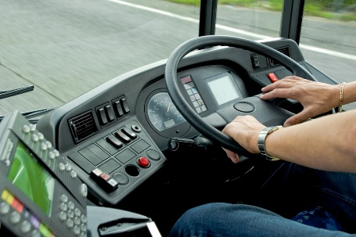
The following provide a comprehensive cross-section of the options available to staff to identify the service requirements for vehicles:
- Researching/reading manufacturer requirements in relation to routine servicing periods and items to be checked and serviced – as prescribed in:
- Warranties and guarantees
- Service manuals
- Owner manuals
- Repair manuals
- Identifying internal vehicle service periods and requirements that may override stated manufacturer’s requirements – this highlights:
- Some organisations elect to service their vehicles more frequently/differently to specifications in owner manuals/manufacturer’s specifications
- The condition of roads over which some vehicles are driven necessitate more frequent attention
- The use some vehicles are put to puts increased stress on the vehicles and demands more frequent service
- Referring to documentation relating to previous servicing that has taken place – which will provide:
- Target date or distance (odometer reading) for the next scheduled service
- Indicate issues which were identified at the last service and flagged for attention at the next service
- Talking with vehicle operators – in order to identify:
- Any on-the-road repairs which may have been made by tour staff or third party providers to the vehicle while (for example) it was on tour
- Items they believe/know require attention
- Issues they have identified as emerging and which, if dealt with, will avoid them becoming an actual problem
- Identifying host country legislation that applies to the maintenance of commercial vehicles used for passenger transport – in order to ensure the safe transport of passengers.
Spare parts
Spare parts for vehicles may be obtained from:
- Authorised dealers
- Specialist parts shops
- Car wreckers.
Always ensure spare parts are suitable for the make, model and year of the vehicle being serviced or repaired.

Ways to identify include reference to:
- Vehicle Owner’s Manual
- Registration sticker
- VIN plate.

Context
In addition to details provided above it is necessary to bear in mind:
- This unit is very much a practical unit – where the focus will be on actually carrying out maintenance and performing minor repairs
- Service and maintenance required for some vehicles can also be determined (to an extent/partially) by:
- The way the vehicle has been driven/who has driven it – the simple fact of life is some drivers are harder on their equipment than others
- Age of the vehicle – generally speaking older vehicles require more frequent service
- History of the vehicle – in terms of the result of combining factors such as distances travelled over time, conditions the vehicle was used in, previous services provided, accidents or incidents the vehicle has been involved in and any damage which has occurred to the vehicle
- Regardless of what is presented in these notes there is always a need to – as appropriate:
- Follow manufacturer’s instructions
- Adhere to organisational SOPs
- Conform to workshop manuals and/or service manuals and/or owner manuals
- Use qualified staff to provide nominated maintenance and/or repairs
- Comply with all local legislation regarding safety and roadworthiness requirements.

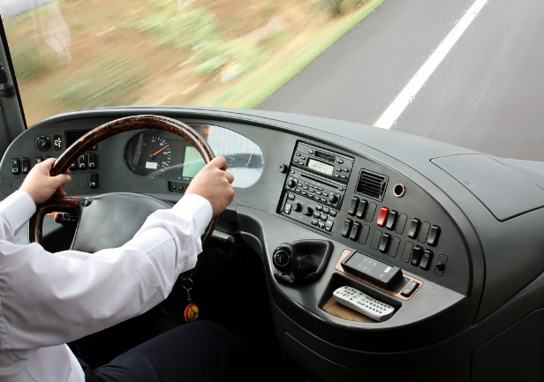

1.2 Determine situations in which maintenance may need to be carried out

Introduction

It is important for all persons with responsibility for maintaining vehicles and carrying out minor repairs to them to understand when these activities may need to be carried out.
This section identifies situations when maintenance and/or minor repairs may be needed.

Examples of situations
Maintenance to and/or minor repairs to tour and travel vehicles may need to be carried out in a range of operating conditions, including:
- Operations conducted at day or night – meaning:
- Not all breakdowns or problems occur during the day
- There is a need to have lighting equipment available to allow work to be carried out on vehicles at night time – such as floodlights, inspection lights, torches
- All weather conditions – meaning there may be a need to take action in the heat of the day, during rain or a storm, and/or in high winds
These conditions may require:
- Waiting – until unacceptable conditions pass and it is safe/safer to take action
- Seeking shade from the sun – or moving the vehicle to a shaded location
- Erecting barricades against the wind/dust/sand – and/or moving the vehicle to a protected position
- Placing the vehicle under cover or putting up a cover of some description – to avoid rain
- In tight or confined spaces – such as:
- In situ in a parking area or parking bay
- When wedged/stuck in an off-road situation – prior to taking other action to retrieve the vehicle
- In closed and controlled locations as well as in exposed and open environments – where:
- Closed and controlled locations can refer to a workshop, depot, base, warehouse or client workplace (office, pick-up or transfer point, muster area) or other position where:
  - There is no danger from passing vehicles
  - There is no adverse impact from the environment/climatic conditions
  - Significant tools and equipment are readily available
  - There is a ready source of spare parts and fluids
  - The vehicle can be moved around, and maintained/repaired in, the location where it is parked
- Exposed and open environments refers to on-the-road and on-tour locations where:
  - Other vehicles are passing or over-taking the vehicle
  - The vehicle is open to the elements – and other factors which might include dangers/risks posed by animals, crowds, rising water
  - Only on-board tools, spare parts and fluids are available

  - The vehicle may need to be moved to a different position in order to allow work to be safely and effectively undertaken – such as off a grade, or away from/out of mud or sand.

1.3 Undertake visual inspections of the vehicle

Introduction
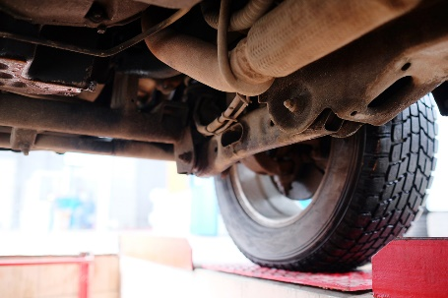
A basic starting point in providing maintenance to a vehicle is to undertake a visual inspection of the vehicle.
This section examines what may be involved in conducting a visual inspection of a vehicle prior to providing service and presents a sample vehicle inspection checklist.

Doing a visual inspection
Provision of service/maintenance to a vehicle is traditionally carried out in closed and controlled situations, even where the vehicle is on-tour.
The inspection process should/could involve:
- Looking at and under the vehicle and closely checking all aspects of the vehicle – while it is:
- On the ground, and/or
- On a hoist or over an inspection pit – if a hoist or inspection pit is not available the inspection can occur by using:
  - Trolley jacks
  - Car stands
  - Under-vehicle car trolleys/creepers.
Checks for specific areas and components of the vehicle are detailed in sections 1.4 – 1.15.
- Lighting the areas being inspected – with:
- Inspection lights
- Torches
- Using a checklist – to:
- Provide evidence the inspection occurred
- Note defects and matters requiring attention
- Inspecting the vehicle in pairs – so that:
- Issues can be analysed/discussed
- A more effective inspection takes place – that is, there is less chance something will be missed if two people do the inspection
- Looking for signs of damage to the vehicle – as these signs can indicate:
- Where a more detailed inspection needs to occur to determine:
- If the damage has caused a problem/further problem
- Whether the damage is a result of another issue

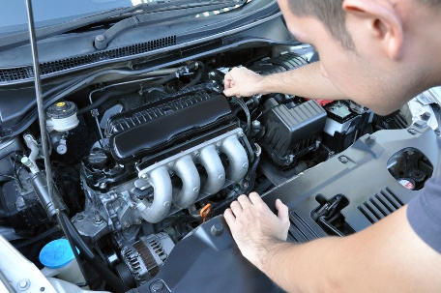
- Need for immediate action – to:
  - Fix the cause
  - Take temporary action to reduce/prevent further damage
  - Keep the vehicle on-the-road/operational
  - Need to take later action – which may not be immediately necessary to
  - Possible cause or source of the damage
  - What may be needed/possible to prevent recurrence
- Checking for missing parts – from:
- Inside the cabin
- Inside the passenger area
- On the exterior of the vehicle
- Under the hood/bonnet
- Noting leaking fluids – as this can:
- Identify type of fluid
- Identify location of leak
- Indicate severity of problem
- Determine, to an extent, the type of problem needing to be addressed
- Identifying projections from the vehicle – this relates to:
- Body parts which have been worked loose, damaged or snagged and are hanging loose or sticking out from beyond the normal dimensions of the vehicle presenting a danger to other vehicles, people or structures
- Items caught up under the vehicle or under wheel wells, around wheels and brake lines, in the engine bay or from vehicle protection bars or lighting bars
- Taking immediate action to rectify problems – which can be quickly and easily fixed on-the-spot, such as:
- Clearing blockages
- Tightening screws, nuts, bolts and fittings
- Checking condition of vehicle instruments – while this is not just a visual inspection it involves a visual element in relation to, for example:
- Confirming travel of pedals and freedom from blockages/interference
- Activating knobs and switches and seeing they function as required.

Vehicle inspection checklist
A vehicle inspection checklist should be used when inspecting a vehicle to record the findings of the inspection.
The following ‘Light Motor Vehicle Inspection Checklist’ is taken from the ‘Light Vehicle Inspection Manual’ provided by the Tasmanian Department of Infrastructure, Energy and Resources, Vehicle Operations Branch available at www.transport.tas.gov.au/standards/, (pp. 12 – 13) and provides a sample checklist which may be used when inspecting a vehicle:
1. | IDENTITY | 8. | UNDER BONNET CHECK | 14. | EXHAUST
 | Compliance plate |  | Master cylinder |  | Exhaust leaks
 | VIN/Chassis No. |  | Engine oil leaks |  | Mountings
 | Engine No. |  | Engine fuel leaks |  | Clearance – hoses/wiring
2. | ELECTRICAL CHECK |  | Air cleaner |  | Catalytic Converter
 | Headlight/parklights |  | Engine mountings | 15. | REAR SUSPENSION
 | Headlight alignment |  | Exhaust system |  | Control arms
 | Tail lights |  | Battery security |  | Bushes
 | Indicators |  | Wiring security |  | Ball joints
 | Brake lights |  | Steering shaft |  | Springs/shock absorbers
 | Reverse lights |  | Steering coupling |  | Bump stops
 | Reflectors |  | Power steering leaks |  | Modifications
 | Lens condition | 9. | STEERING |  | Suspension height __ mm
 | Windscreen wipers |  | Steering box | 16. | WHEELS & TYRES REAR
 | Windscreen washers |  | Steering rack |  | Condition
 | Horn |  | Linkages |  | Tread pattern
3. | BODY CHECK |  | Tie rod ends |  | Tyre speed rating
 | Rust |  | Idler arm |  | Tyre load rating
 | Protrusions | 10. | FRONT SUSPENSION |  | Rims
 | Bonnet safety catch |  | Control arms |  | After market tyres/rims
 | Windows |  | Bushes |  | Wheel track __ mm
 | Window tint % |  | Ball joints | 17. | FUEL TANK

4. | INSIDE CHECKS |  | Springs/shock absorbers |  | Mounting
 | Heater/demister |  | Bump stops |  | Condition
 | Heater fan |  | Modifications |  | Fuel leaks
 | ABS/SRS lights |  | Suspension height __ mm |  | Fuel line
 | Pedal condition | 11. | WHEELS & TYRES FRONT | 18. | LPG GAS
 | Brake pedal height |  | Condition |  | Gas compliance certificate
 | Handbrake operation |  | Tread pattern | 19. | BODY & FRAME
 | Inhibitor switch (auto) |  | Tyre speed rating |  | Rust
 | Steering wheel |  | Tyre load rating |  | Cracks
 | Steering wheel freeplay |  | Rims |  | Bends/kinks
 | Window operation |  | After market tyres/rims |  | Modifications
 | Door operation |  | Wheel track __ mm |  | Mudguards
5. | MIRRORS | 12. | BRAKES
 | Condition |  | Pipes and hoses
 | Mountings |  | Discs and drums
6. | SEATS |  | Calliper/hose security
 | Condition |  | Pads and linings
 | Adjustments |  | Linkages
 | Mountings | 13. | ENGINE & DRIVELINE
7. | SEAT BELTS |  | Mountings
 | Condition |  | Oil leaks
 | Compliance |  | Universal joints
 | Mountings |  | Centre bearing
 | Locking/snatch test

1.4 Check and adjust vehicle structure

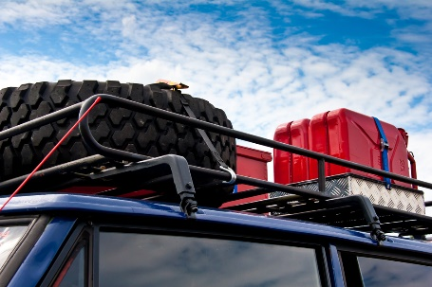
Introduction
It is always important to check and adjust, where possible, vehicle structure as part of service provision.
This section identifies activities inherent in this step.

Context
Many people overlook this vital aspect of maintenance but it is an extremely important topic as it relates to the very foundation of the vehicle and forms the basis onto which much of the other items are connected.
In essence this check seeks to identify:
- If there is damage – to panels (which adversely impact the appearance of the vehicle – see below ‘Appearance of the vehicle’) and/or the structure integrity of the vehicle (which may compromise strength, tracking and handling)
- If there are problems with vehicle stability and suspension – which can present handling, ride comfort and safety problems
- If there are issues with luggage and pack racks – which may cause units to work loose from the vehicle and damage the body, or become separated from the vehicle.

Appearance of the vehicle
In relation to the physical appearance of the vehicle it must be remembered:
- The vehicle nearly always has the name of the tour company on it – so people judge the business by the way the vehicle looks (and the way it is driven)
- People (including tour group members) draw inferences about the tour and the tour organisation based on the way the vehicle looks – as in:
- A well-presented, clean, undamaged vehicle tends to generate confidence in the tour staff and the tour operator
- A poorly presented vehicle that looks dirty and lacking in maintenance will cause concern among tour group members and often cause them to look for problems elsewhere with the tour
- Tour group members expect their tour vehicles to be clean and properly maintained when they commence a tour – and to be appropriately serviced as required while on tour.


Panels
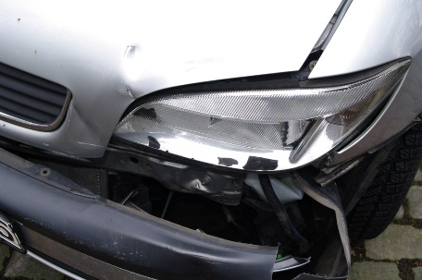
Checking the panels involves a visual inspection.
The best way is to walk around the vehicle and:
- Inspect in a systematic fashion
- Use a checklist to record observations
- Identify and note the location and type of any damage observed
- Determine if obvious panel damage is causing/has already caused operational issues for other components of the vehicle
- Work out if the panel damage has the potential to cause operational issues or further damage to other components
- Hammer out damage which is preventing proper use of the vehicle – or using a pull bar or suction device
- Unbolt or cut away panels which are seriously damaged and present a clear threat to the further operation and/or safety of the vehicle.
More permanent repairs to panels (such as properly removing and filling dents) and other serious panel work, replacing panels, and spray painting, needs to be undertaken by a fully qualified panel beater.

Chassis
Basic inspection procedures are:
- Wash/clean the chassis/vehicle
- Get the vehicle off the ground – a hoist is preferable
- Remove the wheels and tyres
- Focus on corners, wheel arches and bottom of doors.
Chassis (and other) checks require may the use of three basic diagnostic tools/assessments:
- Visual assessment – by getting under the vehicle or raising it on a hoist
- Aural assessment – by listening to the vehicle as it travels over uneven ground
- Functional assessment – by gauging the operation/performance of the vehicle on-the-road.
These assessments should be used to detect:
- Damage – caused by impact with obstacles
- Wear – normal wear and tear occasioned by use of the vehicle
- Breakage – due to stress, misuse, or age.

Specific reasons for concern
The following is taken from the ‘Light Vehicle Inspection Manual’ provided by the Tasmanian Department of Infrastructure, Energy and Resources, Vehicle Operations Branch available at www.transport.tas.gov.au/standards/, identifying some of the presented ‘Reasons for rejection’ (p. 31) under the heading ‘Visually inspect body panels, chassis and sub frame for dangerous protrusions and rust’:
- “Exterior body work and fittings have sharp edges due to rusted panels or body damage, or protrusion of any after-market object of fittings, not technically essential to the operation of the vehicle which protrudes from any part of the vehicle that could cause injury to a person coming into contact with the vehicle
- Any structural member such as a sub frame, floor panel, door sill, seat or seat belt anchorage, is cracked or has advanced rust
- Unrepaired damage or modifications affecting the structural integrity of the vehicle
- Any evidence that body has been cut and joined
- … the doors of a vehicle have advanced rust
- Chassis frame members or supporting members are cracked, loose, sagging or broken
- Frame members in load areas are missing, damaged or unsecured
- Any repairs carried out do not retain the original strength of the component/section
- Any component that adversely affects the safety of the vehicle, and in particular, obscures the drivers view.”

Vehicle suspension

The suspension of the vehicle is important as it affects steering ability, cornering, traction/road holding and passenger comfort. In general:
- Suspension systems may be:
- Gas
- Hydraulic
- Pneumatic
- Mechanical
- Rubber suspension
- Suspension system components may include:
- Lateral and longitudinal/control arms
- Springs – coil, leaf, torsion bars or air springs (to absorb energy)
- Dampers – to dissipate energy
- Shock absorbers
- Linkages
- Ball joints
- Self-leveling devices
- Ride and height controls
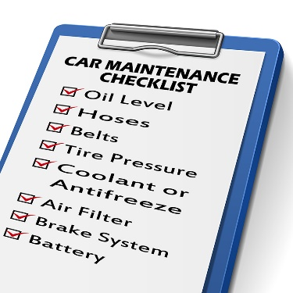
- Diagnostic methods include:
- Functional testing of the vehicle
- Pressure testing of air systems
- Electrical and/or electronic testing
- Visual, aural and functional assessments – with checks for physical damage, corrosion, fluid levels, fluid and grease leaks, air leaks, wear, alignment.
Specific reasons for concern
The following is taken from the ‘Light Vehicle Inspection Manual’ provided by the Tasmanian Department of Infrastructure, Energy and Resources, Vehicle Operations Branch available at www.transport.tas.gov.au/standards/, identifying presented ‘Reasons for rejection’ (p. 55 – 56) under the heading ‘Visually inspect the suspension’:
- “Any suspension component that is broken, cracked, bent, misaligned, cut, missing, not secured or can be seen to have been repaired or modified by heating or welding
- Any shock absorber is missing, inoperative or is leaking fluid
- Any shock absorber is not securely mounted
- Any nut, bolt, or locking device is not secured or is missing
- With the wheels raised, the vertical free play of any wheel exceeds 3mm
- With the wheels raised, the free play of the wheel measured at the rim exceeds 6mm in total or 3mm from any component part.”
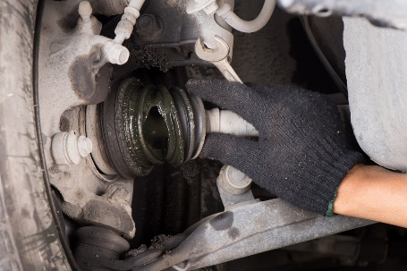
Maintenance
Practical maintenance for suspension can include:
- Adjustment of shock absorbers
- Greasing ball joints, tie rod ends, sway bar links, drag links, centre links, idler arms and Pitman arms
- Inspecting ball joints for play
- Checking wear indicators
- Checking and greasing bearings
- Removing and replacing wheel bearings
- Replacing ball joints and boots
- Checking tyre wear and wheel alignment.


Luggage and pack racks
Luggage and pack racks are attached to vehicles to enable extra gear to be carried.
Some racks and units are purpose built (such as those for carrying bicycles, skis and canoes) while others are more general purpose in nature. Consideration of luggage and pack racks should also embrace consideration of roof boxes, trays and bars (for lights and luggage/goods).
Checks should include:
- Making sure connections are tight
- Cleaning as required
- Replacing missing end plugs
- Checking roof gutters for wear/corrosion – and re-fitting and re-painting where necessary
- Replacement of rubber supports and inserts
- Replacement of frayed/damaged straps
- Oiling moving parts – doors, hinges
- Cleaning roof and rack gutters.

1.5 Check and adjust lighting

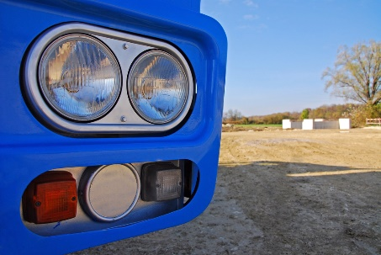
Introduction
All internal and external vehicle lights of the vehicle need to be checked as part of any inspection.
This section identifies the checks which may need to be made.

Checks
The lights which need to be checked will vary with the vehicle being inspected.
Tour vehicles will have more external lighting than conventional vehicles and often a range of internal lighting options.
In addition the lighting associated with dashboard warnings will need to be checked.
For tour vehicles a check should also be made to ensure the spares (globes, fuses) carried in the vehicle are present and correct in the required type, sizes and quantities.
Items which may need to be checked include:
- Headlights – check to ensure:
- Correct colour
- Globes not blown
- High beam – they have good strength and accurate alignment/focus, and illuminate when activated
- Dipped – they have good strength and accurate alignment, and dip and return to high beam when activated: high beam lamps must extinguish when lights are dipped
- Lenses clean and not tarnished or cracked
- Lights are correctly aimed
- No water damage
- Assembly is secure and complete
- Parking light – check to ensure:
- Front and rear are all working
- Lights are clear and clean
- Correct colour
- They illuminate when turned on
- Fog lights – check front and rear fog lights (where fitted) to ensure:
- Correct colour (white or yellow)
- Globes not blown
- Not mounted above level of headlights of vehicle
- Operated on separate switch
- Dip when high beams are dipped
- Do not present a protrusion hazard
- Separated by required gap (for example, 600 mm)
- Do not sit above the bull bar (where fitted)
- Forward facing and correctly aligned/focussed
- Lenses clean and not tarnished or cracked
- After-market lights are tightly connected to vehicle
- Number plate lights – check to ensure front and rear:
- Correct colour (white)
- Operates when lights turned on
- Illuminates number plate
- Clean globe

- Driving lights – check to ensure:
- Correct colour (white or yellow)
- Not mounted above level of headlights of vehicle
- Fitted in pairs
- Maximum four per vehicle
- Operated on separate switch
- Dip when high beams are dipped
- Do not present a protrusion hazard
- Do not have a separate on/off switch
- Do not sit above the bull bar (where fitted)
- Forward facing and correctly aligned and aimed
- Lenses clean and not tarnished or cracked
- After-market lights are tightly connected to vehicle
- Turning indicators – check front and rear, left and right indications to ensure:
- Correct colour (yellow or red)
- Operate when activated
- Clean and clear
- Accompanied by audible signal when activated
- Side marker lights – check to ensure:
- Correct colour (white)
- Illuminate when activated
- Spaced correctly (for example, no less than 400 mm apart)
- Clean and clear

- Brake lights (also known as ‘stop lights’ – check to ensure:
- Correct colour (red)
- Positioned at correct height
- Activated when brake pedal is depressed
- Clean and clear
- No white light shows through the red cover of the light
- Lenses in good condition
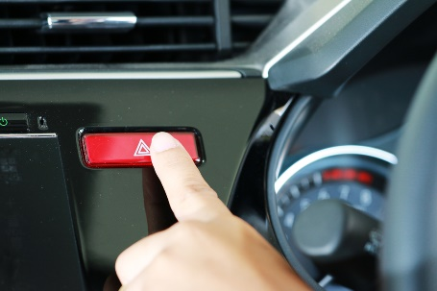
- Hazard warning lights – check to ensure:
- Operate when activated
- All globes operational
- Accompanied by audible signal when activated
- Not incorporated with turn indicators
- Clean and clear
- Reversing lights – check to ensure:
- Activates when reverse gear selected
- Not operated by an independent switch
- Clean and clear
- Activates reversing warning device (where fitted)
- Spotlights (these may be seen by some as ‘driving lights’ and are sometimes used to enable better rear vision at night. Check to ensure:
- Local regulations are complied with – there is usually a ban on fitting spotlights to vehicles other than as in compliance with the requirements for driving lights although some tour vehicles may carry hand-held spotlights which run off the vehicle
- Light bars are securely attached
- No blown globes
- Sufficient intensity
- Rear reflectors – as fitted to the vehicle
- These need to be checked to ensure they are clean and have not become discoloured or dislodged.
- Dirty reflectors need to be cleaned and those which are discoloured or missing must be replaced or tightened.
- Internal lights – these can include:
- Roof lighting inside the vehicle
- Individual passenger ‘reading’ lights
- Map-reading lights
- Boot and cargo compartment lights.

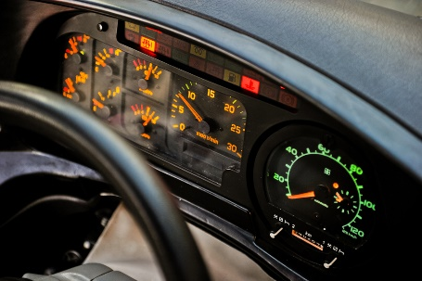
Checks need to address:
- Operate when turned on/off
- Clean and clear – globes and covers
- No blown globes
- Dashboard and instrument illumination – check to ensure:
- Illuminates when lights are activated
- Dimming facility operates (where fitted)
Warning (or ‘tell tale’) lights (the owner manual needs to be consulted to ensure there is complete knowledge of all warning lights fitted to the vehicle) – check to ensure, for example:
- Seatbelt light and audible warning activates if seat belts are not connected
- Dashboard warning activates when hazard warning lights are operated
- Turn signal dashboard light illuminates when turn signal used – left and right
- Required lights (for example: oil, temperature, brake system, temperature, battery and others) illuminate:
- As required
- When vehicle is turned on.
See the 28 possible dashboard lights identified and described at http://www.2pass.co.uk/dashboard-lights.htm#.VRnnqI6ddh8.

Adjustments
The basic adjustments for lights (depending on the identified problem) are likely to be:
- Replace blown globes
- Clean lenses and reflectors
- Align/focus headlights, driving lights and fog lights as/if required
- Replace wiring or re-wire lights as required to conform to requirements
- Replace fuses
- Replace wiring
- Replace connectors
- Tighten loose fittings.
Technical adjustments may require the services of a qualified auto electrician.

1.6 Check and adjust vision-related items

Introduction

To optimise general safety and enhance tour group enjoyment of their tour it is important to check vision-related items.
This section discusses requirements relating to windscreens, windows, mirrors and related items.

Checks
The following may require checking:
- Glazing – check to ensure:
- Tinting is not excessive and permits sufficient light to pass in accordance with local regulations – that is, tinting for front and front-side windows must not be ‘too dark’.
- There may be no restrictions for:
- Passenger windows located rear of the driver
- A limited band (say, maximum 10% of the total windscreen) at the top of the windscreen
- Sun visors – check to ensure:
- Fully operational and easy/smooth to use – in terms of:
- Flipping down and up
- Moving laterally – where appropriate
- They will stay in the position required by the user
- They are securely affixed to the vehicle
- Additions (mirrors, pockets, attachments) are clean and secure
- Windscreen wipers and washing system – check to ensure:
- System is fully functional at all settings – and blades return to their resting position when the system is turned off
- Water jets are correctly aimed and of sufficient pressure
- Water jets are operating properly and are not blocked or disconnected
- Wipers and washers can be operated from the driver’s seat
- Blades of the wipers make contact with/sweep only the glass and no other part of the vehicles
- Blades are in place and in good condition – that is, they are not dried, cracked or otherwise damaged or defective
- Demisters – check to ensure:
- The demister operates correctly when turned on – and removes condensation from inside the windscreens as required for the individual design and requirements of the vehicle.

Rear vision mirrors

The following is taken from the ‘Light Vehicle Inspection Manual’ provided by the Tasmanian Department of Infrastructure, Energy and Resources, Vehicle Operations Branch available at www.transport.tas.gov.au/standards/, (p 32):
It states the objective of visually inspecting the rear vision mirrors is “To ensure that the mirrors and associated components are in such a condition that the driver has a clear field of vision by reflection of the road behind the vehicle and any following or overtaking vehicles at all times under the normal range of climatic conditions.:
The Manual lists ‘Reasons for rejection’ as follows:
- “Rear vision mirrors are cracked, loss of reflectivity, missing, or do not provide a clear view of the road to the rear of the vehicle.
- Where there is no effective rear vision provided by the internal rear vision mirror, the vehicle does not have an external rear vision mirror fitted to each side.
- Any light commercial vehicle (except a station wagon) is not fitted with an external rear vision mirror on each side of the vehicle.
- Mirrors are not securely mounted.
- Mirrors are obscured.
- The right side rear vision mirror fitted to a vehicle over 3.5 tonnes Gross Vehicle Mass (GVM) is not fitted with a flat reflecting surface.”
The ‘Roadworthy Requirements’ established by Vic Roads (see link from https://www.vicroads.vic.gov.au/searchresultpage?q=toadworthiness%20requirements) states, in relation to rear vision mirrors (p. 9):
- The rear view mirrors must provide a view of the rear of the vehicle from the driver’s seat
- Mirrors must be securely mounted and able to be adjusted
- The reflective surface must not be cracked, broken or peeled
- The primary rear vision mirror must be flat but additional curved ones may be fitted.

Windscreen and front side windows
The following is taken from the ‘Light Vehicle Inspection Manual’ provided by the Tasmanian Department of Infrastructure, Energy and Resources, Vehicle Operations Branch available at www.transport.tas.gov.au/standards/, (pp. 29 – 31) and can be used/adapted to apply to all windows in any vehicle.
It states the objective of visually inspecting the windscreen and front and side windows is “To ensure that the windscreen, windows and associated components are in such a condition that the driver has a clear field of vision at all times under the normal range of climatic conditions.”
The same objective in tour vehicles obviously applies to tour group members.
The ‘Light Vehicle Inspection Manual’ presents the following reasons to reject a vehicle when inspecting it in this regard:
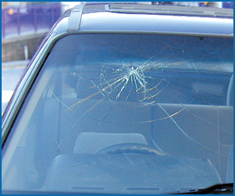
- “The area of windscreen from the centre of the vehicle in front of the driver has cracks or is deteriorated to the extent that it interferes with the driver’s view
- The wiped area of the windscreen in front of and on the same side of the vehicle as the driver has
1) damage (such as scoring, sandblasting or severe discolouration) that interferes with the driver’s view
2) any bulls-eye or star fracture that exceeds 16 mm in diameter, or any two (2) of the following
i) hairline crack up to 30 mm long
ii) a crack from the edge of the windscreen up to 75 mm long
NOTE: Grooves in windscreens that are designed specifically to clean the wiper blades are not regarded as damage unless they affect the driver’s view. Approved grooving is usually identified by the installer
- Any cracks in a laminated windscreen penetrate more than one layer of glass or are more than 150 mm long
- Any glazing used in any motor vehicle is not safety glass (except a caravan) and where ADR 8 applies, the glass does not display an identification mark or symbol. [See http://www.infrastructure.gov.au/roads/motor/design/ for more information on Australian Design Rules]
- Tint films are not free of bubbles, scratches or other defects that significantly affect the driver’s vision
- Glazing is loose in its frame or cracked to the extent that sharp edges are exposed
- Glazing, other than the windscreen, that is necessary for the driver to see the road is discoloured, obscured, badly scratched, sandblasted or fractured to the extent that it interferes with the driver’s view
- Items that obscure the driver’s view … [on either side of the windscreen]
- At least half the number of windows must be capable of being opened or the vehicle must be provided with an alternative method of ventilation
- Windscreens are removed and not replaced.”

Adjustments
The basic adjustments for vision-related items will depend on the identified problem but may include:
- Cleaning
- Tightening or re-affixing connections and fixtures
- Replacement of faulty or defective items
- Professional service by qualified technician to electrical/electronic items.

1.7 Check and adjust entrances and exits

Introduction
For all passenger-carrying and commercial vehicles there is a need to inspect the entrances and exits.
This section considers the checks and possible adjustments which may be involved.


Items to check
The following may require checking:
- The operation of all doors of the vehicle – including:
- Hinged doors
- Sliding doors
- Pneumatic doors
- The operation of other opening panels/parts of the vehicle – such as:
- Bonnet
- Boot
- Cargo holds
- Side/drop doors
- Aspects of the vehicle allied to entrances and exits – such as:
- Entry steps
- Ramps and hoists
- Pneumatic supports – used to keep doors open
- Emergency exits.

Checks
Checks should focus on:
- Ensuring latches and catches are mounted securely, in good condition and operating correctly and effectively as required – every door/opening (left and right, front and back – and top of vehicle, were sun-roofs are fitted) needs to be physically tested
- Making sure doors which are controlled by the driver can be opened and closed from the driving position
- Checking to make sure all door attachments/fittings and fixtures are securely attached – and do not present a protrusion hazard
- Testing and checking the operation of door handles and locks – including the operation of remote opening/locking devices
- Verifying bonnets which are hinged at the rear of the bonnet (near the windscreen) have an effective secondary bonnet mechanism (catch or straps) in place – to prevent the bonnet flying up if the primary catch fails
- Making sure gas/pneumatic struts support the panels/vehicle sections they are intended to support – and do not allow that area to drop or unintentionally lower slowly or close without notice
- Ensuring entrances and exits are free from tripping hazards – such as worn rubber, torn carpet, or lifted seals/strips
- Verifying steps are fitted with skid- or slip-resistant covering
- Checking illumination of steps (as/if fitted) and lighting of other spaces accessed by doors is functioning correctly – and there are no blown globes
- Checking presence and stability of hand rails and hand straps for passengers – at entrances/exist and at each seat (where provided)
- Operating mechanical and pneumatic devices provided on the vehicle (which may include steps, ramps, hoists) – to determine devices work as required (all functions – stop, start, hold, up, down and other as relevant) using all control unit options (such as those in the driving cabin as well as remote or hand-held units.
Emergency exits

Inspecting the emergency exits (where provided) should address:
- Emergency exits are clearly identified/signed and have clear operating instructions posted
- Equipment/items to operate/access the exit are in place – such as tools to break windows
- Exits are free from obstructions and physically undamaged.
The ‘Roadworthy Requirements’ established by Vic Roads (see link from https://www.vicroads.vic.gov.au/searchresultpage?q=toadworthiness%20requirements) states, in relation to rear vision mirrors (p. 8) indicates:
“Emergency Exits
Emergency exits on buses must be clear of obstruction and must be clearly identified, with the method of opening clearly indicated unless obvious from the design. The exits must appear capable of being readily operated.
Emergency Exit Warning Devices
The warning devices provided on all emergency exits other than service doors and breakable glass emergency exits must be present and serviceable.
The warning must be given when the engine is started and/or vehicle is in motion, if
- The primary opening or ejection device is moved
- An emergency exit is locked from the outside
- An emergency door or window is not securely closed.
The warning device must provide a visible and audible warning to the driver and must activate with movement of the catch or other device securing the emergency exit, not only by movement of the emergency exit itself.”

Adjustments
The basic adjustments for entrances and exits will depend on the identified problem but may include:
- Cleaning
- Removing obstacles
- Greasing and oiling moving parts
- Using dry lube for door strikers
- Using powdered graphite on door locks
- Replacing batteries on remote locking devices/keys
- Replacing seals
- Changing blown globes
- Re-gassing struts
- Providing scheduled maintenance to pneumatic and mechanical devices as prescribed by the manufacturer
- Tightening or re-affixing connections and fixtures
- Replacing faulty or defective items
- Obtaining professional service by qualified technician to mechanical and/or pneumatic items.


1.8 Check and adjust vehicle interior

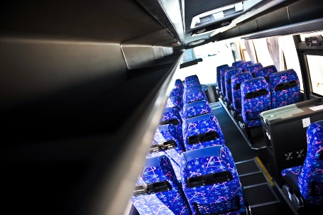
Introduction
The interiors of all vehicles need to be checked for a range of safety and passenger comfort factors.
This section identifies items which may need to be inspected and provides sample checks and adjustments which may be required.

Checks
Seats
Checks should focus on making sure:
- Seat anchorage points are not cracked or rusted
- There are no missing parts/fasteners in the seat frames or anchorage points
- There are no exposed/sharp edges or protrusions – which may cut/harm people
- Every seat has a seat cushion and backrest – and will provide basic/required level of comfort for passengers
- Seat adjustments (for example, seat height and angle, lumbar support, position of backrest, forward and rear movement/slides) are fully functional – and hold the designated position as required
- Required space around (in front of and in between) seats is provided – in accordance with the type and size of the vehicle as prescribed by relevant transport authority.
Head restraints
Checks should focus on ensuring:
- All seats are fitted with a head restraint/head rest
- Every head rest is securely fitted and in good condition
- Head rests can be adjusted as required – and maintain the position they are adjusted to.
Aisles
Checks should focus on verifying:
- It is clear of obstructions
- There is no torn/ripped of frayed carpet or floor covering – to present a tripping hazard
- Lights illuminate the aisle – where fitted
- Compliant height for the aisle – which can vary between bus types (and their use) and can (for example) range from a minimum floor-to-roof height of 1.2 metres (for very small buses) through different measurements up to 1.8 metres for large buses
- Minimum width for the vehicle type is complied with – these can range from (for example) 300 mm in a small bus up to 380 mm in a larger bus.

Seatbelts
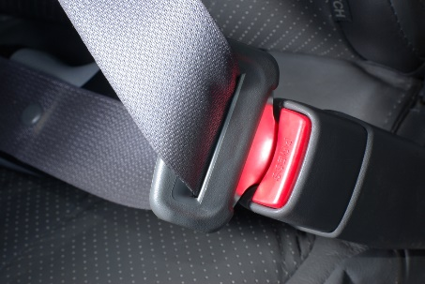
Checks should focus on making sure:
- Seat belt anchorage points are not cracked, damaged, distorted or rusted
- No part of the unit is missing
- The retractor mechanism, locking mechanism, buckle, tongue or adjustment device is working correctly and effectively
- Seatbelt webbing is not (‘Light Vehicle Inspection Manual’, Tasmanian Department of Infrastructure, Energy and Resources, Vehicle Operations Branch available at www.transport.tas.gov.au/standards/, (p. 36)
- Damaged
- Frayed
- Stretched
- Tied in a knot
- Twisted
- Split
- Torn
- Cut
- Altered or modified
- Severely deteriorated
- Burnt
- Not correctly and firmly secured to each end fitting
- Has webbing/stitching which is detached at any point.
Airbags
Checks should focus on determining:
- If the warning light for airbags is illuminated and stays lit (or flashes) when the engine is started – after the system has performed its own self-test
- If the airbag has been deployed or tampered with
- That bull bars fitted to the vehicle have been done such that the effectiveness and operation of the airbags has not been compromised
- Relevant seats are correctly positioned – according to manufacturer’s instructions – there are optimum/recommended positions for driver and passenger seats
- Vehicles carry necessary advisory signs regarding availability and location of vehicle airbags
- Nothing has been attached to the airbag cover – which could become dangerous projectiles in the event of airbag deployment
- No-one has disconnected the airbags which were supplied with the vehicle.
Important note: Death and serious injury has resulted from the accidental deployment of airbags during service/maintenance by unqualified persons.

Heating and ventilation
Checks should focus on confirming:
- Operational effectiveness of the heating and cooling system:
- At all settings
- In all sections of the vehicle
- From all operator panels
- No leaks or drips from the system
- No collapsed, perished, disconnected or kinked leads or hoses
- Windows and roof hatches can be easily opened and closed
- No harmful gases are introduced as a result of any heating or cooling process
- Temperatures generated are suitable – for the requirements of the business/tour operator
- The demister operates correctly when turned on – and removes condensation from inside the windscreens as required for the individual design and requirements of the vehicle
- No strange noises – when the system is operated
- Advisory lights illuminate (where fitted) – when system activated
- No air locks in the system.
On-board signs and instructions
Checks should focus on ensuring:
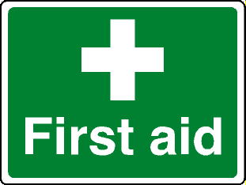
- All required signs are in place – in the required locations, to indicate for example:
- On-board toilets
- Fire extinguishers
- First aid kits
- All instructions are in place – in the required locations, to indicate for example, how to use:
- Fire suppression equipment
- On-board entertainment and leisure items
- Vehicle facilities
- Information is legible
- Metal signage do present skin penetration hazards
- Signs are firmly affixed.
Emergency passenger signals
Checks should focus on ensuring:
- Where the driver of the vehicle is segregated from passengers by a partition or other obstruction there is some alternative way the driver can be contacted by passengers in the case of an emergency
- The alternative method operates effectively and is in good condition.
Audible warning devices
Checks should focus on verifying the horn:
- Is fitted and operational when used
- Is sufficiently loud enough
- Can be activated easily from the driver’s seat
- Produces a continual, single-pitch tone.

Adjustments
Adjustments which may be necessary for the interior of a vehicle may include:
- Cleaning including removing leaves, dirt and debris from component parts
- Repairing and/or replacing torn/damaged seating, carpet, floor coverings and other internal fabrics/coverings
- Tightening loose fittings
- Replacing deployed or malfunctioning airbags
- Replacing worn, faulty or perished hoses and connections
- Removing items placed over airbag covers
- Replacing seatbelts which have been used when the vehicle was involved in an accident
- Draining hoses and units
- Re-charging air conditioning units with gas – or making arrangements for same
- Re-priming heating systems
- Acquiring, replacing and/or (re-) affixing signs.


1.9 Check and adjust brakes

Introduction

An obvious and important check to make of any vehicle is the braking system.
This section looks at checks to make for vehicles and trailers and list possible adjustments which may need to be made.

Checks for vehicles
Based on the advice provided in the ‘Light Vehicle Inspection Manual’ provided by the Tasmanian Department of Infrastructure, Energy and Resources, Vehicle Operations Branch available at www.transport.tas.gov.au/standards/, (pp. 17 – 18), there can be a need to:
- Ensure brake pedal is properly covered with rubber and there is no metal showing through
- Verify rubber on brake pedal has anti-slip surface and that surface is sufficient and in good condition
- Ensure the brake pedal or the hand brake is not physically broken
- Check the travel/height of the brake pedal when applied and ensure it is within manufacturer specifications – for example, less than 20% travel
- Determine if the brake pedal moves to the floor/towards the floor (or if the brake indicator/warning light comes on) when steady pressure is applied for 10 seconds
- Ensure brake warning light illuminates when engine is turned on
- Ensure hand brake warning light illuminates when hand brake is applied – and extinguishes when the hand brake is released
- Make sure the hand brake stays locked in position when applied
- Make sure the brake pedal and the hand brake return to the fully released position when not being used
- Test the brakes to ensure they slow/stop the vehicle as required (within stated requirements: that is, within a given distance from a nominated speed – for example, within 11 metres from a speed of 35 kph)
- Inspect the brake pipes, hoses and connections for signs of damage or severe deterioration, kinks, crimping, heat damage or visible signs of leakage, swelling or bulging
- Inspect the brake pipes, hoses and connections to verify they are securely mounted, and not cracked or broken
- Inspect visible brake components looking for signs they are broken, excessively worn, leaking, contaminated or not securely mounted
- Verify hydraulic lines are of sufficient length to allow for the full range of steering and suspension movement, and are not twisted
- Check any repairs made to hydraulic lines have been made in accordance with applicable standards (for example, they have not been made through heating or welding, and parts used comply with required ratings/standards)
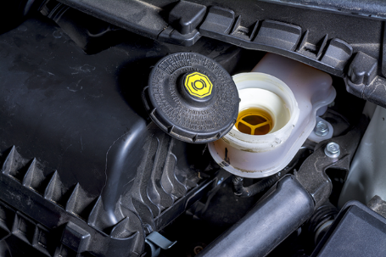
- Check brake fluid and verify it is at required level
- Check visible brake lining material to ensure it is worn to less than manufacturers limits or if the limits are not known 0.8mm above bonded shoe or pad mounting surface and level with the rivet or bolt heads on riveted or bolted lining
- Inspect power/vacuum assistance for brakes to make sure they are operating properly
- Check to ensure compressors, vacuum pumps and/or pulley belts are not cracked, loose or worn
- Look for evidence of leaks from the system (any joint, component or seal).

Checks for trailers
Based on the advice provided in the ‘Light Vehicle Inspection Manual’ provided by the Tasmanian Department of Infrastructure, Energy and Resources, Vehicle Operations Branch available at www.transport.tas.gov.au/standards/, (pp. 65 – 66), there is a need to:
- Verify the trailer has brakes which conform to requirements relating to weight/size and year of manufacture
- Inspect the visible components of the system – checking:
- There are no leaks
- Mountings are secure
- Cables are operative, effective and in good condition
- Wiring for electrical brakes is in good condition
- Brake fluid it is at required level
- Brake fluid reservoir for hydraulic brakes is appropriately sealed
- Brake lines are in good condition – no bulges, leaks, corrosion
- All repairs made to hydraulic lines have been made in accordance with applicable standards
- No brake component is seized, severely corroded or inoperative or, where visible, is worn beyond manufacturer’s limits
- Test trailers fitted with over-ride brakes – by compressing the brake-actuating device and attempting to move the trailer (usually this can only be carried out where a parking brake is fitted to the trailer)
- Test parking brake (with towing vehicle in neutral and its brakes off) – where fitted to ensure the trailer cannot move when brake is applied, and the brake stays in the required position
- Test trailers fitted with brakes other than override brakes – by attaching the trailer to a tow vehicle, applying the trailer service brake and attempting to move the trailer forward: the brake should stop movement of the trailer
- Inspect emergency braking system/brake away braking system – where fitted the emergency braking system/brake away braking system should automatically apply when the trailer is detached from the towing vehicle.

Adjustments
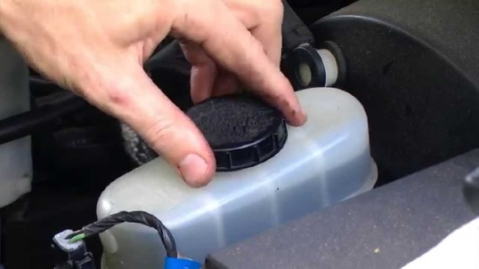
It is important to note:
- Given the importance of the braking system to staff and passenger safety many organisations insist service/repairs to the braking system of vehicles are undertaken by qualified mechanics
- Vehicles deemed unsafe in this aspect must be removed from service immediately – and tagged so they are not driven by anyone
- Management must be notified immediately – so they can begin making whatever plans/changes are required to accommodate the fact a vehicle is out-of-service.
Depending on the identified problem there may be a need to:
- Replace rubber on the brake pedal
- Replace broken, damaged, defective, worn or suspect parts – as opposed to repairing them
- Take the vehicle to an auto electrician – to have electrical/warning light problems or frayed electrical wiring replaced/fixed
- Top-up brake fluid
- Replace leaking seals using required kits
- Arrange for, or perform, machining and/or re-conditioning of brake drums and brake disc rotors
- Adjust the hand brake – which may require renewing cables
- Replace brake pads (disc brakes) or shoes (drum brakes)
- Replace the brake fluid (bleed the brakes and re-fill the system)
- Replace wheel cylinder (drum brakes)
- Replace the master cylinder and servo unit
- Replace brake hoses
- Adjust disc brakes.

1.10 Check and adjust steering


Introduction
All inspections of vehicles must include coverage of the steering.
This section presents indicative checks and possible adjustments.

Checks
The ‘Roadworthy Requirements’ established by Vic Roads (see link from https://www.vicroads.vic.gov.au/searchresultpage?q=toadworthiness%20requirements) states, in relation to steering:
“The vehicle steering system … must be free from wear or play exceeding the manufacturer’s limits and the vehicle must track satisfactorily without undue wander.
All steering components, including dust and grease seals, must be in good condition securely and correctly mounted and free from damage and excessive wear,
All nuts, bolts and other fasteners used on steering components must be secure and fitted with appropriate retaining or locking devices, where necessary. There must not be binding in the steering system from lock to lock.
Power steering
Any power steering pump or associated or associated components must work and be securely mounted. Hoses, pipes and drive belts, etc must not foul any other components in a manner likely to cause failure. All fittings must be free of oil leaks, however, dampness or staining around seals is acceptable. The reservoir must be correctly filled.” (p. 4)
And at p.9:
“Steering wheel rims, knobs and other devices, which have deteriorated to an extent that they are hazardous are unacceptable. Steering wheel covers, if fitted, must be secure.”
In addition the following is based on information in the ‘Light Vehicle Inspection Manual’ provided by the Tasmanian Department of Infrastructure, Energy and Resources, Vehicle Operations Branch available at www.transport.tas.gov.au/standards/, (pp. 23 – 24 and 33) in relation to steering:
- With the engine running, check the operation of the steering by moving the steering wheel – to ensure:
- There is here is no more than 50 mm rotational free play in the wheel
- The steering wheel is free from structural damage
- Any accessories fitted to steering wheels (padded hubs, covers etc.) are not loose
- The steering wheel is securely attached to the steering column
- Where a SRS airbag is fitted, there is any evidence airbags or other SRS system are operative: check the indicator light, where fitted - this usually illuminates when the ignition is first switched “on” and extinguishes after the system passes a self-test.

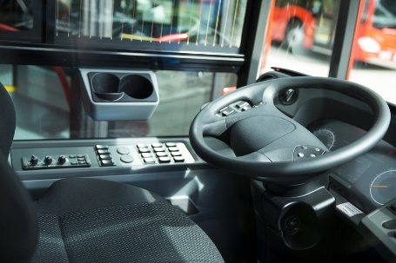
- Visually inspect all steering components under the bonnet and under the vehicle – to ensure:
- No steering component is missing, cracked or broken or is worn beyond manufacturer’s limits
- No steering component can be seen to have been repaired or modified by bending, heating or welding (unless in accordance with manufacturer’s specifications)
- No nut, bolt or locking device is missing or insecure
- Tie rod and drag link ends are secured in both the rod and taper with fasteners suitably locked (e.g. split pins, lock-wire, tabs or self-locking nuts)
- There is no movement on the spline between Pitman arm and the steering box or between any thread or tapered joint
- No free play due to wear in any steering component which exceeds manufacturer’s specification (if that specification is not known, free play exceeds 3 mm)
- Power steering has no leaks, no defects and is not inoperative
- Any manual or power steering componentry is securely mounted and free from excessive side or end play, roughness, or binding
- Power steering belts are not loose, broken, frayed, missing, or cracked through to reinforcing plies
- Check the operation of the anti-theft/steering lock – to ensure:
- The ignition key cannot be removed in any position except the “anti-theft” (lock) position
- When engaged, the anti-theft lock prevents at least one of the following actions:
- Steering the vehicle
- Engaging the forward drive gears
- Release of the brakes.
‘How a Car Works’ (http://www.howacarworks.com/steering) suggests the following is done and shows how to do so:
- Check steering box mountings
- Check steering-rack security
- Check steering swivel pins
- Check steering joints for wear
- Check the steering box
- Check rack-and-pinion steering.

Adjustments
Adjustments need to respond to identified problems and may include:
- Arrange for professional repairs to be made where serious issues are identified and/or where work involving airbags needs to be done
- Replace worn/loose steering wheel covers
- Replace damaged steering wheels
- Tighten nuts, bolts, connections, fasteners and steering wheel accessories
- Replace defective/leaking seals
- Replace missing, cracked, broken or excessively worn components
- Top-up power steering fluid
- Secure tie rod and drag link ends where required
- Replace defective/damaged hoses, pipes and drive belts
- Adjust and replace power steering drive belt
- Adjust toe alignment on wheels
- Lubricate steering swivel joints
- Replace track rods and (track rod end) ball joints
- Set the tracking.


1.11 Check and adjust exhaust

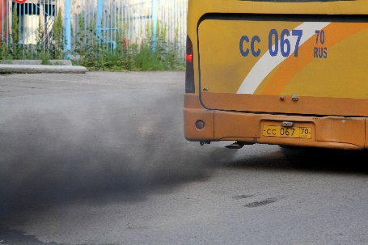
Introduction
The exhaust system must be checked as it has the potential to cause issues with noise, safety and vehicle performance.
This section identifies the points to check and the possible adjustments which may need to be made to a vehicle’s exhaust system.

Checks
General requirements are to check for:
- Internal fumes
- External smoke
- Noise.
The check should also look for fluids which may be dripping onto the exhaust system from other vehicle components.
Based on the ‘Light Vehicle Inspection Manual’ provided by the Tasmanian Department of Infrastructure, Energy and Resources, Vehicle Operations Branch available at www.transport.tas.gov.au/standards/ (p. 42), the checks should ensure:
- There are no visible cracks
- The system is securely mounted – across its entire length
- An effective silencer if fitted and operational with all exhaust gases passing through it – so vehicle noise is not excessive in accordance with local regulations/mandated noise levels
- Outlet of the exhaust pipe is to the rear of passenger side doors and opening windows
- Exhaust discharges:
- Rear of vehicle
- To the correct side of the vehicle (left or right) depending on which side of the road the vehicle is driven on – fumes/exhaust must not be directed at footpath-side
- No leaks, holes or corrosion in the system – apart from intentional drain holes provided by manufacturers in mufflers
- The exhaust pipe exit extends beyond the vehicle body but not beyond the overall plan of the vehicle – so the pipe does not end under the body but extends to under the rear bumper bar
- The system does not interfere with or obstruct any part of the steering, suspension, brake or fuel system
- The entire system at its lowest points clears the road surface by the required distance – for example, 100 mm
- The exhaust does not let out sparks, flames, excessive gases, oil or fuel residue
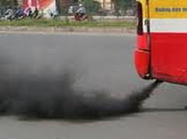
- No visual emissions from the exhaust for longer than 10 seconds after the engine has been started
- Where fitted, emission control equipment is all present and fully operational
- LPG fuel lines are separated from exhaust components by the required distance (say 150 mm) and/or protected by a shield and separated by a lesser distance, say 50 mm.
The ‘Roadworthy Requirements’ established by Vic Roads (see link from https://www.vicroads.vic.gov.au/searchresultpage?q=toadworthiness%20requirements) states, in relation to exhausts (p. 6) indicates:
- “Vehicles manufactured to comply with emission control ADRs must have all pipes, hoses, valves, sensors, fuel and air control devices and any other emission control equipment originally fitted by the vehicle manufacturer properly located and connected and not apparently damaged, deteriorated or altered in any way so as to appear ineffective”
- “Dual fuelled vehicles must retain any emission control equipment fitted to enable them to meet emission requirements while operating on petrol”
- “For vehicles fitted with a four-stroke engine, exhaust emissions (except water vapour) must not be visible to the naked eye for more than 10 seconds under normal operating conditions. When running, the engine must not discharge excessive crankcase fumes and where crankcase ventilation equipment is fitted it must be secure and leak free.”
Page 8 states:
- “All seals at body openings necessary to prevent the entry of gases into any passenger area must seal effectively.”

Adjustments
Adjustments required may include:
- Replacing seals
- Replacing mountings
- Replacing damaged, sub-standard and defective parts – rather than repairing them, or patching leaks/holes
- Attaching missing parts/components
- Re-routing the system – to comply with legally imposed requirements
- Tuning the vehicle.

1.12 Check and adjust towing connections

Introduction
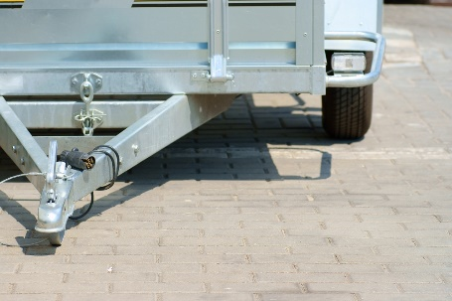
Many vehicles will be fitted with tow-balls and towing connections so these will also need to be checked as part of the visual inspection.
This section discusses the checks which need to be made and the potential adjustments which may be required.

Checks
Based on the ‘Light Vehicle Inspection Manual’ provided by the Tasmanian Department of Infrastructure, Energy and Resources, Vehicle Operations Branch available at www.transport.tas.gov.au/standards/ (pp. 54 – 55), the checks should ensure:
- There are no cracks or other visible physical damage in any part of the towing attachment
- The towing attachment is secure/not loose
- Towing bar is fastened securely to the vehicle
- No visible corrosion on bolts/any part of the towing connection
- Towing connection is suitable for the weight to be towed – and the vehicle displays (where and as required) an appropriate label to this effect
- No temporary repairs or welds (especially where drawbar is marked ‘Do Not Weld’ by the manufacturer) have been made to the connection
- Electrical wiring, couplings and connectors are securely fastened and in good condition
- An effective secondary locking system for the trailer
- Tow-ball assembly is securely attached
- Safety chains and/or cables are in good condition – and:
- Can be affixed so they cannot be accidentally detached
- Are securely attached to the drawbar
- Safety chains are rated for the weight to be drawn – and in the required number
- All required parts of detachable tow units are in position/present in the assembly
- Jockey wheel is in position, firmly attached and fully functional.

Adjustments
Adjustments required may include:
- Replacing defective parts – rather than repairing them
- Removing un-rated chains and replacing them with chains which are stamped and correctly rated – for the intended towing weight
- Cleaning and greasing the jockey wheel.

1.13 Check and adjust miscellaneous items

Introduction
In addition to the preceding checks there is also a need to check and, where necessary adjust, a range of miscellaneous items.
This section presents a representative list of checks which may need to be made and adjustments which could also be required.

Engine and fuel systems
Checks
Checks will depend on age and condition of the vehicle, identified issues and type of vehicle/engine, but may involve:

- Checking condition (colour and viscosity) of the engine oil
- Checking date/odometer reading for timing for draining and replacing engine oil
- Checking level of oil in the engine
- Checking the oil pump
- Checking the fuel pump
- Checking for leaks/evidence of leaks
- Checking condition of oil filters
- Checking overhead valves/clearances
- Checking condition of air filters
- Checking carburettor/s
- Checking the points
- Checking condition of the distributor and its operation
- Checking spark plugs, gaps and distributor leads
- Checking idle speed of the motor
- Ensuring required grade of oil is being used according to manufacturer recommendations (who usually provide a chart for determining the grade of oil to use under different conditions) and intended use of the vehicle:
- SAE 10 is thin
- SAE is thick
- Some are blended/multi-grade: such as 20W/50.
See http://www.nairaland.com/1054692/knowledge-101-which-engine-oil
- Checking fuel lines/fuel delivery pipes and clips and connections.

Adjustments
The adjustments will depend on the identified issues and on the type of vehicle/engine, but may involve:
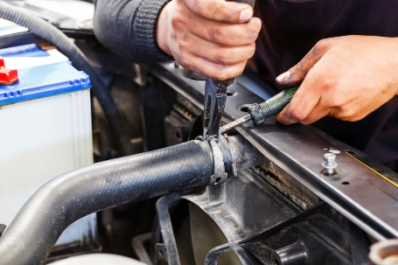
- Taking action to stop/prevent leaks
- Replacing gaskets and oil seals
- Topping up engine oil
- Changing engine oil
- Changing oil and/or fuel filters
- Replacing oil and/or fuel pumps
- Cleaning or replacing air filters
- Replacing points
- Cleaning, adjusting and/or fitting kits to carburettors
- Replacing exhaust manifold gaskets
- Adjusting the tappets/re-set clearances
- Adjusting camshaft timing belt
- Replacing suspect/damaged hoses
- Replacing plugs, cleaning plugs and/or adjusting gaps
- Adjusting the ignition timing
- Changing fuel mix
- Replacing distributor cap and rotor
- Tuning the motor
- Replacing fuel lines, clips and connections.

Transmission
Checks
May include:
- Checking gearbox oil level
- Checking axle oil
- Looking for leaks
- Checking automatic transmission fluid level and colour
- Testing automatic transmission inhibitor switch
- Checking clutch cable and linkages.

Adjustments
Representative adjustments could include:
- Taking action to stop/prevent leaks
- Draining and re-filling gearbox
- Replacing transmission oil seals
- Changing rear axle oil/axle oil
- Topping-up or changing automatic transmission fluid
- Adjusting free-play in, or replacing, the clutch cable.

Electrical wiring
Checks
Should include:
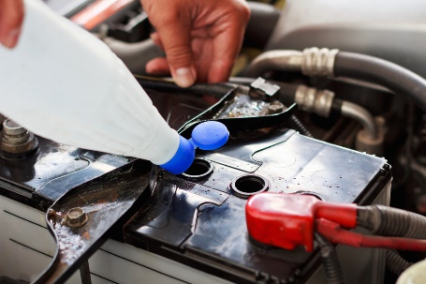
- Testing operation of all electrical items on the vehicle
- Visually inspecting all visible wiring looking for scorch or rub marks, exposed wiring or loose or missing connections
- Using multi-meter to check current, voltage and resistance readings
- Checking battery water level
- Checking battery charge
- Checking battery leads, posts and connections
- Checking alternator drive belts/pulleys
- Checking brackets and mountings
- Checking fuses
- Ensuring required spare fuses are in place.
Adjustments
Representative adjustments (which may need to be done by a qualified auto-electrician) could include:
- Re-wiring the vehicle
- Topping up battery water with distilled water
- Cleaning terminals and points
- Charging and/or replacing batteries
- Replacing defective components
- Relacing fuses.

Water
Checks
- Checking level of radiator water
- Checking water in windscreen washer reservoir
- Checking radiator hoses and connections
- Checking radiator cap
- Checking water pump
- Inspecting for leaks and evidence of leaks
- Ensuring spare water containers in vehicles are full
- Checking operating temperature of engine.
Adjustments
May include:
- Topping up water to required levels
- Adding detergent to windscreen washer water
- Flushing radiator
- Removing and replacing radiator
- Draining and re-filling sealed systems
- Replacing water pump
- Arranging for re-coring of radiator
- Replacing thermostat
- Adding cooling system additives, if/where required.
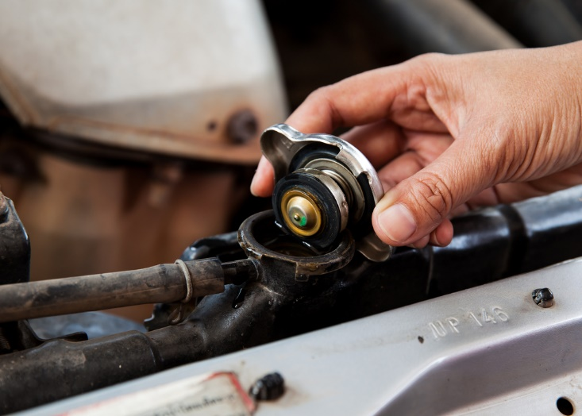

Tyres
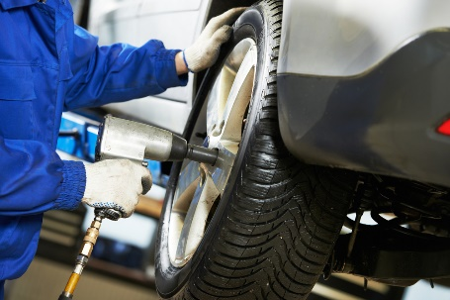
It can be best to remove wheels for checking/inspections.
Checks
The checks may cover:
- Checking general condition and wear on each on-road tyre plus the spare tyre, including condition of sidewalls
See http://www.howacarworks.com/wheels-and-tyres/avoiding-tyre-wear - Avoiding tyre wear
- Inspecting condition of wheels and rims
- Checking tyre pressures
- Testing valves for leaks
- Verifying all tyres are of the same tread pattern
- Verifying all tyres are the correct size
- Verifying all tyres have sufficient tread
- Verifying all tyres are suitably rated for required loads and speeds – according to tyre manufacturer charts
- Testing any on-board compressors or manual or foot-operated pumps loaded onto tour vehicles – to:
- Verify proper operation
- Compare pressure shown on gauges against pressure shown on workshop tyre pressure gauge
- Ensuring on-board tyre repair kits are present and fully stocked.
Adjustments
There can be a need to:
- Make arrangements for qualified tyre specialists to:
- Do wheel alignment
- Do wheel balancing
- Fit new tyres and wheels
- Repair punctures/leaks
- Re-fit valves
- Inflate or reduce pressures as required
- Clean tyres and wheels, removing mud and debris inside and out
- Replace defective compressors
- Check/replenish tyre repair kits – comprising plug kits, spare valve cores, caps and the four-way valve tool
- Rotate tyres/wheels.

On-board personal services/facilities and systems
Checks
Depending on the vehicle and the operator these may require:
- Physically checking operation of toilets – Including:
- Operation of seat cover
- Operation of door and locking mechanism
- Physically checking operation of sinks – Including:
- Operation of hot water heater
- Operation of hot and cold water and taps
- Operation of plugs and drainage
- Operation of hand drying facilities
- Operation of soap dispenser
- Physically checking operation of the radio – including:
- Operation of station selection and AM/FM selector
- Operation of volume and other controls
- Visual displays
- Condition of speakers – with attention to physical damage and clarity of sound
- Condition of the aerial
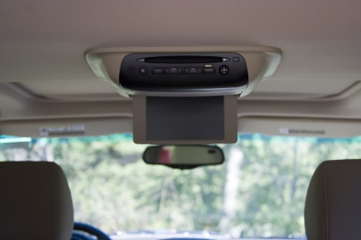
- Physically checking operation of television – including:
- Operation of channel selection
- Operation of volume controls
- Condition of speakers – with attention to physical damage and clarity of sound
- Clarity of picture
- Operation of DVD facility
- Operation of remote control unit
- Visual displays
- Condition of the antenna
- Physically checking operation of audio-tape systems – including:
- Operation of volume and other (fast forward, rewind) controls
- Condition of speakers – with attention to physical damage and clarity of sound
- Operation of remote control unit
- Visual displays
- Physically checking operation of public address systems – including:
- Operation of volume controls
- Condition of speakers – with attention to physical damage and clarity of sound
- Operation of microphone
- Physically checking operation of installed two-way (CB and UHF) radios – including:
- Operation of volume controls
- Operation of channel selection
- Visual displays
- Condition of speakers – with attention to physical damage and clarity of sound
- Condition of the aerial/s

The maintenance of hand-held communication devices is the responsibility of the persons who use the vehicle/use the units
- Physically checking operation of all options and facilities for all installed electronic and/or electrical devices – such as:
- Global positioning systems (navigation aids)
- On-board cameras and recording equipment
- Battery management
- ECUs
- Asset management (RFID/vehicle tracking)
- Physically checking operation of other items specific to individual types of vehicles.
Adjustments
These might require:
- Cleaning – especially dust and dirt
- Replacing tap washers
- Lubricating moving parts in toilet and wash systems
- Changing batteries in remote-control/hand-held units
- Replenishing bathroom/toilet supplies (or this may be done by cleaning staff)
- Reading the ‘User Manual’ for the vehicle or for the individual on-board system to:
- Identify required service/preventative maintenance requirements
- Diagnose the cause of faults/problems
- Effect necessary repairs
- Making arrangements for qualified service technicians to service/repair the items
- Tightening/securing brackets and connectors
- Upgrading GPS maps as required
- Replacing unserviceable items (or making arrangements for same).

1.14 Check and adjust load restraints

Introduction
It is to be expected some vehicles being serviced will feature load restraints.
This section identifies a range of basic load restraints, lists checks to make and presents possible adjustments which may need to be made.

Checks
Checks should include:
- Load anchorages – inspecting and testing to:
- Ensure they are securely mounted and have not worked loose
- Make sure there is no visible rust/corrosion to the anchorages or surfaces to which they are attached

- Retention devices, baggage and cargo restraints – inspecting and testing to:
- Ensure they remain securely fitted and have not worked loose
- Verify operation as intended
- Confirm effectiveness and suitability for loads/items to be secured/restrained
- Make sure there is no corrosion to steel components
- Check condition of straps, webbing and nets – no rips, missing parts, damage, deterioration
- Count/examine number of cords/straps to ensure they are all present
- Confirm operation of ratchets and rollers
- Make sure D-rings and other attachments/connectors are in place, undamaged and fully-functional
- Cab guards – these are the devices designed to protect people in the cab of a vehicle from intrusion of items coming in through the rear window during an accident or a quick stop/hard braking
Inspecting and checking should verify:
- Mounting points are secure and solid
- Unit is rigid and fully covering the window being protected
- No corrosion/rust near mounting/anchor points
- No damage to the unit which compromises its integrity
- No loose parts
- Mesh/wire has not broken/become unattached and become a hazard for people to cut themselves on
- Required vision from the cab is not obstructed


- Headboards, sideboards and tailboards – inspecting and testing to ensure :
- Operation as intended – opening and closing/moving up and down
- Boards are securely attached to the vehicle itself
- Boards can be securely locked in position
- No fasteners are missing or loose
- No evidence of rust or corrosion – at mounting points and on boards themselves
- No evidence of cracks or fractures
- No proof of significant damage or distortion – which impacts function and/or presents a hazard
- Curtain systems – these are the flexible curtains commonly used on the side of vehicles/trucks to contain loads.
Checks need to ensure:
- They are not ripped/torn or have not otherwise deteriorated or been damaged
- They are securely attached to the frame which supports them – and the frame is securely attached to the vehicle
- Previous repairs made to the fabric/material remain satisfactory
- Correct rating system/curtain is being used (where applicable) – and relevant certificate is available
- Curtain tensioning components are fully functional, secure and in good condition.
See http://alcsafety.com.au/wp-content/uploads/2013/03/RLSC-LR-Curtains-Rev2r.pdf for more.

Adjustments
Adjustments required may include:
- Cleaning
- Welding broken/damaged parts
- Replacing straps, webbing and nets
- Replacing anchor points, bolts and/or other connectors
- Repairing and/or replacing boards and curtains
- Replacing defective parts – where repairs cannot be successfully undertaken
- Greasing moveable parts
- Fitting items where revised use of vehicles indicates need to do so.

1.15 Check and replenish on-board emergency equipment and supplies, where necessary

Introduction
A standard aspect of checking all business and tour vehicles is the need to check and replenish emergency equipment and supplies.
This section identifies checks which may need to be made and actions potentially involved in replenishment activities.

Standard items
There may be a need to check the following:
- Jack/s for the vehicle – with attention to:
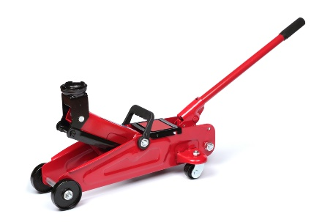
- Verifying designated vehicles have the correct type/s of jacks stowed on board – for example, sedans for city/local use may have just one standard jack (as supplied by the car manufacturer) while 4WDs may also be required (under organisational SOPs) to also carry a high-lift jack or some other secondary lifting system
- Making sure all components of each jack are present and located in their designated position
- Checking a wheel brace is provided
- Confirming physical operation of the jacks
- Greasing jack screws as required
- Tool kit – as provided for the vehicle, in terms of:
- Confirming presence of all items using a checklist to guide and record the inspection/check
- Replacing missing items
- Spare parts – as required for the vehicle, in terms of:
- Confirming presence of all items using a checklist to guide and record the inspection/check
- Replacing missing items
- Adding new items – in accordance with expected/upcoming vehicle use
- Spare tyre/s – to check:
- Inflation
- Load and speed rating
- Tread pattern and depth
- Condition of wheel, rims and sidewall of tyre/s

- Tyre chains – checking:
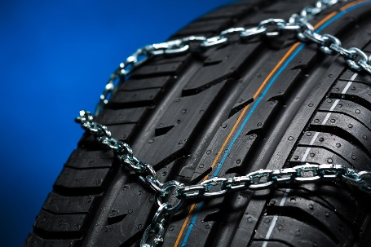
- Sufficient wheel chains are present – there must be chains for all the drive wheels, at least
- Appropriate gloves are available for user to wear when fitting chains
- Chains are the right size for the tyres of the vehicle
- Hooks and links are sound – there should be no missing links or obvious damage
- Tyre studs – checking:
- Tyres have sufficient tread depth – and holes are clean
- Sufficient studs are available for the type and number of tyres to be studded
- Available studs are correct length to match stud holes in the tyres to be fitted
- Stud gun is used to insert studs
- Studs are removed from tyres where they are not required – including spare tyre/s
See more at:
http://www.tirerack.com/winter/tech/techpage.jsp?techid=151 – Studded tyres for winter driving
http://www.tirerack.com/winter/tech/techpage.jsp?techid=124 – Stud removal from tyres
https://www.youtube.com/watch?v=BC6Kp-1gtc0 – Studding tyres: GW stud gun.
- Recovery equipment – which may involve checking:
- Operation of electric winch and presence of recovery blanket – including hand-held operating unit for winch, all functions
- Presence of snatch strap and shackles
- Availability of safety/recovery gloves and tree trunk protector
- Availability of snatch blocks
- Availability of tyre gauge
- Availability of rails/tracks.
See more at:
http://www.tjm.com.au/en-oceania/recovery-equipment - Commercial site
http://www.maxtrax.com.au/faq - Commercial site
http://www.arb.com.au/products/recovery-equipment/ - Commercial site.

Additional emergency items
It is possible the service of the vehicle may also require certain other items provided in the vehicle to also be checked, as follows.
Fire extinguishers
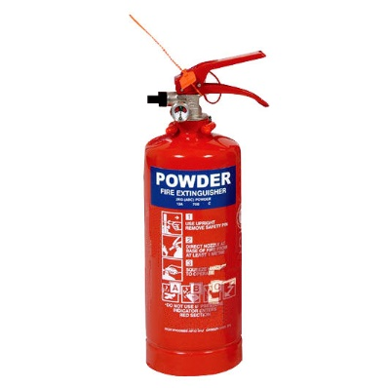
Checks need to address:
- Vehicle is supplied with mandated type/rating and number/s of fire – where applicable, for example for passenger-carrying vehicles/tour vehicles
- Extinguisher is located in correct, suitable and accessible position
- Extinguishers have been regularly inspected – commonly, every six months by certified officer/nominated agency and these inspections have been logged
- Where extinguisher has a pressure gauge, the indicator is in the green section – if not, the extinguisher must be re-charged
- Extinguisher has not been used – if it has been used it must be re-charged or replaced
- Nozzles are clear – and free of obstructions
- All parts of the extinguisher are present and are not damaged
- Holding brackets are tight/secure and the extinguisher is securely mounted
- All maintenance is documented/recorded
- Stamped tag is attached to the extinguisher – as required by local agencies.
First aid kits
Checks may need to address:
- Verifying the required number of kits are available – in the designated locations
- Confirming presence of all items using a checklist to guide and record the inspection/check
- Confirming presence of First Aid book
- Confirming presence of disposable gloves and mask
- Replacing missing items
- Adding new items – in accordance with expected/upcoming vehicle use/tour.
Emergency Position Indicating Radio Beacon
Checks on the EPIRB should address:
- They are provided in/for all vehicles which are designated as needing to use them – such as tour vehicles and those to be used in remote locations
- They are registered initially – with the relevant authority/agency
- Registrations are renewed as required – such as every two years even where there is no change in the registered owner
- Testing – in accordance with manufacturer’s instructions taking care not to accidentally initiate a false alarm
- Checking battery dates – and:
- Replacing before listed expiration date of the battery
- Replacing if the unit has been used
- Inspecting the unit for physical damage, cracks or other defects
- Logging details of the checks, tests and maintenance performed.
Maintenance
EPIRBs cannot be maintained by users.
Where problems are identified with EPIRBS the recommended course of action to:
- Forward to the manufacturer or their agent
- Replace the unit with a new one ensuring it is registered prior to being put into use.



1.16 Make arrangements for external service provision where requirements cannot be accommodated internally

Introduction

Where vehicles cannot be services within the organisation there is a need to arrange for them to be externally serviced.
This section identifies factors to consider in the process and presents steps which are usually.

Factors to consider
Issues which can influence the need to take a vehicle to an external provider for service may include:
- Extent of work which needs to be done – smaller jobs may be handled internally but larger jobs tend to be sent out
- Timeframes which apply – where there is a definite or tight timeline for the completion of work, it can be better to have the work done by a professional
- Safety issues – anything which relates to matters of safety tends to be undertaken by suitably qualified technicians and service people so as to discharge the common law Duty of Care imposed on businesses
- Complexity of the job – simple jobs may be done in-house but the more difficult work tends to be outsourced
- Tools and equipment available – where specialist tools and equipment are required for work it can be more economical to get outside businesses to do the job
- Expertise – there will just be some jobs where organisational personnel have no experience and no real idea of what to do so there is an obvious imperative for the work to be done by experienced professionals
- Terms of warranties and guarantees – in order to maintain the protection/coverage provided by some warranties and guarantees there can be a need for specified work to be done by ‘authorised dealers or agents’.

Steps in the process
When making arrangements for service to be done on vehicles by an external provider, the following may be required:
- Track use of the vehicle – so:
- Odometer readings are monitored – as service times are usually related to distances travelled
- Projected date for service can be identified
- Advance bookings can be made – with service providers


- Notify management or administration – and:
- Advise them of the situation and the reason for external service provision
- Discuss known details of the work required
- Give an estimate of cost, if known
- Identify urgency of work that needs to be done
- Tell them of any bookings/identified up-coming use for the vehicle
- Determine if quotations are required – and if so, how many
- Seek and obtain formal approval to proceed
- Identify the relevant service provider – this may be:
- The organisation from which the vehicle was purchased
- The authorised dealer for the make
- The preferred service provider as determined by the business
- An approved repairer as designated by a recognised motoring body or insurer
- Speak to the selected business by phone or in person – and:
- Advise of the nature and extent of work required
- Explain urgency of work required and need for vehicle to be returned to service by given date, if applicable
- Take the vehicle in to the business – for them to see/inspect
- Request quotation for the work to be done – if necessary
- Schedule the work – to:
- Best integrate repairs with any other work to be done – so as to minimise down-time
- Maintain vehicle ‘in service’ for maximum time – providing it is safe to do so
- Make a booking for the work to be done – with the chosen provider which may be chosen based on:
- Quotation received
- Ability to perform the work by required date
- Previous experience with the business
- Direction from management, warranty/guarantee or insurer
- Take necessary other action – which may entail:
- Ensuring vehicle is not used until the required repairs have been completed, where safety is a concern
- Re-arranging vehicle usage sheets to accommodate absence of the vehicle
- Hiring/renting another vehicle to replace the one being repaired
- Advising known vehicle users of changes made.

1.17 Comply with mandated safety requirements while undertaking service

Introduction
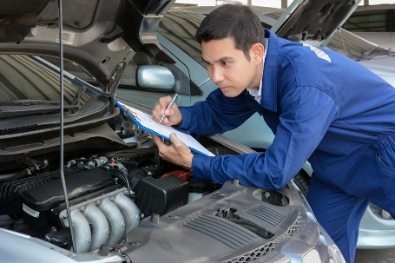
It is critical to comply with mandated safety requirements when undertaking vehicle service.
This section addresses the need to consider personal safety as part of the process, discusses possible need for compliance with external authorities, and presents an example of legislated safety obligations as they apply to employers and employees.

Basic safety requirements
When servicing vehicles:
- Taking responsibility for personal safety – people must take responsibility for their own safety regardless of all other protocols
- Being alert to the possibility of risk – due to faulty equipment, risky practice, introduction of a new product or procedure into the workplace: being aware the workplace is a dangerous environment and has the potential to cause injury is the biggest, single factor in taking the initiative for safety at work
- Warning others of hazards – so they avoid them
- Learning workplace safety policies and procedures – what applied at a previous workplace may not apply at the current workplace
- Understanding a hazard can exist today that did not exist yesterday – due to the dynamic nature of work
- Realising a remedy for one workplace risk can introduce a new/other workplace hazard
- Reporting any workplace risk/hazard – as soon as it is identified
- Keeping the work area neat and tidy – as this helps create a safety-oriented mind set: there seem to be fewer accidents and injuries in neat and clean workplaces
- Wearing clothes that are fit for the job – no hanging threads, loose sleeves: wear/provide safe and comfortable clothes
- Reporting ‘near misses’ as well as actual accidents/injury – so investigation and preventative action can be taken
- Looking out for the safety of others – other staff and members of the public
- Immediately ceasing any work as soon as it becomes dangerous – rather than ‘pressing on’ in dangerous conditions
- Participating in workplace safety discussions, inspections, feedback and management – so workplace safety is consultative
- Adhering to SOPs, SWPs and manufacturer’s instructions – as these have been developed with safety in mind
- Wearing/using designated PPE as directed – such as eye protection, gloves, steel-capped boots

- Using all appliances, equipment, tools as directed – making sure the right tool is used for the right job
- Intervening when a dangerous workplace situation is identified – to protect people/others against injury
- Taking care when working, which includes:
- Not rushing
- Thinking about what needs to be done
- Thinking about how to do what needs to be done
- Not doing anything believed to be unsafe
- Taking practical action when required, such as:
- Picking up items from the floor when they have been dropped
- Cleaning up spills immediately – instead of ignoring them or leaving them for someone else to do
- Disposing of glass (including broken glass) into designated containers
- Undertaking a first aid course – so help can be provided if necessary
- Being trained in workplace health and safety – as it applies to the workplace, and attending all workplace-based health, safety and welfare training
- Not working when unfit to do so – as a result of tiredness, injury, other causes
- Seeking to establish a safe place/working environment – rather than relying on employees working in a safe manner
- Applying safe manual handling protocols – in relation to moving and lifting objects in the workplace
- Ensuring there are MSDS for all chemicals used in the workplace – and they are readily available to workers
- Handling chemicals according to established safe chemical handling, storing and usage protocols – as developed by the organisation for the chemicals used within the business
- Abiding by the requirements of health, safety and welfare legislation – as it applies locally/nationally: see ‘Workplace safety and health’ below
- Including health and safety training as part of the Induction and Orientation – for all new employees
- Ensuring suitable first aid kit is present/available
- Ensuring a fire extinguisher is close-by – just in case it is needed.

External compliance
Where repairs are made to vehicles (and trailers) – and perhaps where nominated service has to be provided – there can be a need to have this work inspected and ‘passed’ by local transportation, vehicle or road authorities.
These requirements may apply to all vehicles, or just to those registered as commercial and/or passenger-carrying.
Where these obligations apply it is generally the case:
- The vehicle must be taken or driven to the inspection point
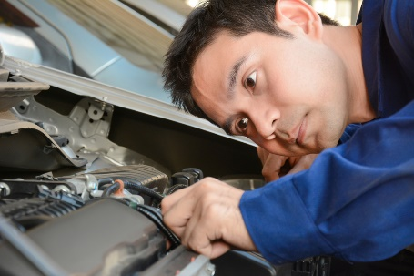
- It must be inspected, checked and approved by an authorised officer of inspector
- A certificate approving the repairs must be issued and obtained to sign-off on the repairs before the vehicle is legally allowed to be driven/used on the roads.
If the vehicle fails inspection:
- The authority will provide a list describing extra work that needs to be done to make the vehicle safe/roadworthy
- The vehicle needs to be repaired further, as required
- The vehicle must be re-presented for inspection and approval.

Workplace safety and health
As an example of what may apply, consider the requirements of the Workplace Safety and Health Act for Singapore and what it covers.
In states (at http://www.mom.gov.sg/workplace-safety-health/wsh-regulatory-framework/Pages/workplace-safety-health-act.aspx) in relation to employer obligations it states:
“You must, as far as reasonably practicable, protect the safety and health of employees or workers working under your direct control, as well as all who may be affected by their work. Your duties include:
- conducting risk assessments to remove or control risks to workers at the workplace
- maintaining safe work facilities and arrangements for the workers at work
- ensuring safety in machinery, equipment, plant, articles, substances and work processes at the workplace;
- developing and implementing control measures for dealing with emergencies
- providing workers with adequate instruction, information, training and supervision.”
The same legislation, and web page, goes on to present obligations imposed on workers as follows:
- “You must follow the safe working procedures and principles introduced at the workplace
- You must not engage in any unsafe act that may endanger yourself or others working around you
- You must use, in proper manner, any personal protective equipment, devices or other means provided to secure your safety, health and welfare while working. You must not tamper or misuse such items provided
- You must not engage in any negligent act that may endanger yourself or others working around you.”

Work Projects
It is a requirement of this Unit you complete Work Projects as advised by your Trainer. You must submit documentation, suitable evidence or other relevant proof of completion of the project to your Trainer by the agreed date.

1.1 To fulfil the requirements of this Work Project you are required to provide scheduled service to vehicles approved by your Trainer/Assessor providing evidence you have:
- Identified necessary minor servicing requirements for specific vehicles
- Determined situations in which maintenance may need to be carried out
- Undertaken visual inspections of the vehicle
- Checked and adjusted vehicle structure
- Checked and adjusted lighting
- Checked and adjusted vision-related items
- Checked and adjusted entrances and exits
- Checked and adjusted vehicle interior
- Checked and adjusted brakes
- Checked and adjusted steering
- Checked and adjusted exhaust
- Checked and adjusted towing connections
- Checked and adjusted nominated miscellaneous items
- Checked and adjusted load restraints
- Checked and replenished on-board emergency equipment and supplies
- Made arrangements for external service provision
- Complied with mandated safety requirements while undertaking service.

Summary

Provide scheduled service to vehicles
When providing scheduled service to vehicles:
- Identify prescribed servicing requirements according to manufacturer’s specifications/vehicle manual
- Refer to previous service history of the vehicle
- Talk to vehicle users
- Factor in relevant legislated requirements
- Observe warranty obligations
- Visually inspect the vehicle for indications of leaks, problems, damage and defects
- Use a vehicle inspection checklist to record and detail findings of the inspection
- Check and adjust vehicle structure and lighting
- Check and adjust vehicle vision-related items and vehicles entrances and exits
- Check and adjust vehicle interior and miscellaneous items
- Check and adjust vehicle brakes and steering
- Check and adjust vehicle exhaust
- Check and adjust vehicle towing connections and load restraints
- Check and replenish on-board emergency equipment and supplies.

Element 2:
Diagnose minor vehicle faults

2.1 Identify minor faults

Introduction
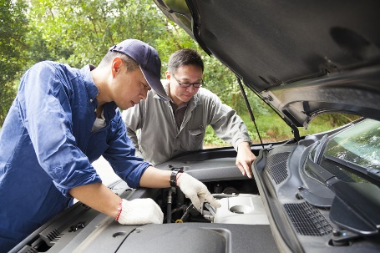
There are several ways to identify minor vehicle faults.
This section describes the standard ways to identify the presence of minor faults so they can be diagnosed.

Basic actions
There are four basic ways to identify vehicle faults:
- Talking with those who have operated/driven or been in a vehicle
These people may be drivers or passengers
Actions required include:
- Asking open and closed questions
- Asking probing questions
- Using terminology appropriate to the individual – such as avoiding complex automotive terms if the person does not understand them
- Listening to what is said
- Getting them to point to locations
The discussion should aim to:
- Identify type and nature of fault
- Describe the fault if it cannot be identified
- Explain whereabouts it is located (if appropriate)
- Describe symptoms and indicators
- Give an idea of frequency of the problem
- Identify conditions under which fault occurs/presents
- Test driving the vehicle – to:
- Attempt to induce the fault – which can often be a frustrating experience as a problem ‘on tour’ often fails to manifest itself on return
- Listen to sounds made by the vehicle
- Get a feel for the vehicle – and how it handles and responds
- Smell any odour which may be generated by the fault
- Duplicate causal conditions which were known to trigger the problem

- Compare the way it is ‘now’ to how it normally behaves – in some cases a ‘fault’ with a vehicle as identified by someone else can simply be a ‘lack of performance’ which is really not a fault but simply the standard operating parameters of the vehicle
- Running stationary vehicle to induce fault – which may involve:
- Applying handbrake and/or chocking vehicle
- Running vehicle from a cold start
- Starting vehicle from a hot start
- Running vehicle with nominated accessories turned ’on’ (and/or ‘off’) as required
- Running vehicle for nominated period of time
- Monitoring/observing vehicle from inside and/or outside of the vehicle
- Reading reports which have been prepared on the vehicle – such as:
- Roadworthy/unroadworthy certificates
- Vehicle defect notices
- Service reports
- Daily vehicle inspection checklists
- End of Tour reports
- Damage reports
- Maintenance requests
- Usage log.


2.2 Determine cause of faults

Introduction
When a fault has been identified it next remains to determine the cause.
This section presents standard procedures used for doing so.


Context
Identifying the cause of faults may also be known as:
- ‘Diagnosing’ faults
- ‘Troubleshooting’.
In many cases the reality of this stage is:
- It is not straight-forward
- The process can be very time consuming
- It is difficult to re-produce the fault so the cause can be found
- It can be harder to determine the cause than it is to fix the fault.

SOPs for diagnosing faults
Determining the cause of vehicle faults may include:
- Analysing available information (‘evidence’) as obtained from the fault identification process to provide a list of tests to perform in order to:
- Generate/cause the fault
- Test options
- Eliminate possible causes in a structured and sequential, one-at-a-time basis
- Identify causes
- Using diagnostic flowcharts – as provided by manufacturers for different parts/components of the vehicle
- Using on-board diagnostics (OBD) – which require a purpose-built scanning tool to (reader) be plugged into the on-board computer to display and interpret a Diagnostic Trouble Code which describes the fault
- Referring to service and operator manuals – as most minor faults can be determined with reference to these books
- Seeking additional advice from the manufacturer – which may take the form of:
- On-line advice – using:
- Free, password protected access to contracted assistance provided as part of new vehicle purchase
- Fee-for-service specialist advice
- Over the phone assistance – from the manufacturer or the agent/business that sold the vehicle
- In-person help – which may include:

  - Talking face-to-face with the Service Manager at the agency
  - Taking the vehicle in to the business for one of the mechanics to look at and give free-of-charge advice on – this is a viable option where the organisation purchases significant vehicles from the one car dealership and/or where a ‘preferred supplier’ arrangement exists with the business
- Referring to personal experience – the more experience a person has in diagnosing faults, the greater their pool of experience becomes
This personal experience generates a useful source of information as it is based on ‘legitimate’, first-hand practice
- Loading vehicle onto jacks, stands or a hydraulic lift – in order to:
- Get a better look at the vehicle and be able to see ‘up and under’ it and the engine bay. Certainly, raised vehicles always make it easier to identify the location of leaks and drips
- Free up certain suspension components
- Make it easier to manipulate other parts of the vehicle
- Using applicable sensory appraisal to help determine cause – this is similar to using the senses to help identify a fault in the first place, and can (depending on the issue) rely on:
- Sight
- Feel
- Smell
- Hearing
- Monitoring on-board instrument panel – which can mean watching and interpreting the readings of:
- Temperature gauges
- Tachometers
- Oil pressure
- Battery charge
- Monitoring externally attached equipment – such as:
- Various diagnostic tools
- Battery/alternator testers
- Vacuum and fuel pump testers
- Electronic brake service tool
- Compression test
- Circuit testers and multi-meters.

Work Projects
It is a requirement of this Unit you complete Work Projects as advised by your Trainer. You must submit documentation, suitable evidence or other relevant proof of completion of the project to your Trainer by the agreed date.
2.1 To fulfil the requirements of this Work Project you are required to diagnose minor faults with vehicles approved by your Trainer/Assessor providing evidence you have:
- Identified a required number of minor faults
- Determined the cause of the identified faults.

Summary

Diagnose minor vehicle faults
When diagnosing minor vehicle faults:
- Talk to vehicle operators
- Test drive the vehicle
- Run the vehicle
- Read vehicle reports
- Identify location and nature of the fault
- Analyse available information to determine cause/s of the fault
- Use diagnostic tools to assist with diagnosis
- Seek help when necessary.

Element 3:
Undertake minor repairs to vehicles

3.1 Remove, repair and/or refit vehicle components


Introduction
It can be necessary to remove and re-fit various components to a vehicle in order to perform a range of basic repairs.
This section describes indicative work needed to complete several of the common requirements in this regard.

Important notes
In relation to this section it is vital those undertaking repairs note:
- Performing repairs to vehicles which are still under warranty can void the warranty – so there is a need to check this before proceeding any further
- The actual work required may differ between makes and models of vehicles – the procedures listed in the notes are indicative only
- Always be prepared to read Owner’s manual or Workshop manual
- Obtain the right parts before starting the job
- Obtain and use the right tool/s for the job
- Work steadily – never rush a job
- Check the surrounding areas/sections for debris and/or damage at the same time – and respond as indicated
- Never be afraid of asking for help, advice or direction from a more qualified or experienced person.

Replacing globes
To replace a light globe:
- Identify the light to be replaced
- Obtain correct globe for the job – sealed units will require the entire headlamp to be replaced; semi-sealed units only require the light globe
- Remove the light cover/dust covert
- Unplug electrical connector
In some cases there is a need to remove the entire light assembly to replace a light globe.
- Disconnect whatever mechanism is used to keep the old globe in place
- Remove the old globe noting how it sits – bayonet globes are removed by rotating them anti-clockwise
- Put the new globe in position taking care not to touch the glass part of the globe with the fingers
- Re-attach the mechanism, electrical connection and cover
- Test the light to make sure it is working.
See the following for more help:
http://www.supercheapauto.com.au/how-to/Outside-the-Car/Checking-and-Changing-an-Automotive-Light-Globe.aspx?id=79 – Checking and changing an automotive light globe
https://www.youtube.com/watch?v=6hURsa46t4M – How to change a headlight bulb
https://www.youtube.com/watch?v=jk1kFc56dwk – How to replace headlight bulbs
https://www.youtube.com/watch?v=cB99QN1AYBU – How to install replace front lower side reflector
https://www.youtube.com/watch?v=mgGWFqPe0Ms – Headlight bulb replacement service: 2005 Honda CRV
https://www.youtube.com/watch?v=5F31wzh60zo – How to replace taillight
https://www.youtube.com/watch?v=9POigqpLxQc – How to replace fog light and bulb.

Replacing a fan belt
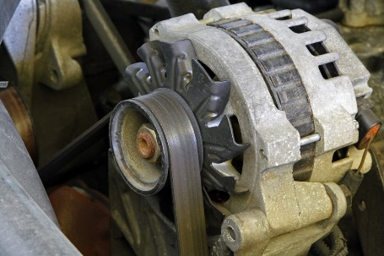
Actions are:
- Release tension on old belt at bolt on tensioner rail
- Move alternator to allow free play in old belt
- Remove old belt
- Fit new belt by looping it over alternator and water pump pulleys
- Re-locate the alternator to bring tension on the new belt
- Tighten the bolt on the tensioner rail
- Run the engine to test for:
- Squealing noise – indicating belt is slipping and needs to be re-tensioned
- Dashboard warning lights – which may indicate a problem.
See also:
https://www.youtube.com/watch?v=4hnOUs9eiN4 – Change a fan belt
http://www.supercheapauto.com.au/how-to/Servicing-Mechanical/Replacing-a-Drive-Belt.aspx?id=76 – Replacing a drive belt
https://www.youtube.com/watch?v=Wg1AX77xEBQ – How to replace a serpentine belt
https://www.youtube.com/watch?v=01J3Fp9_bMA – How to replace a serpentine belt: Toyota Corolla
https://www.youtube.com/watch?v=XD0LNkFYPGQ – Toyota timing belt
http://www.wikihow.com/Change-an-Automotive-Belt.

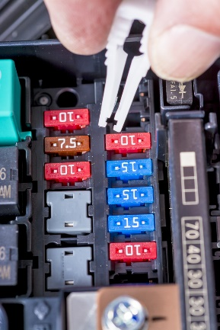
Replacing a fuse
Indicative steps are:
- Locate fuse box/block
- Remove cover
- Read key on cover (or in manual) to determine the fuse to replace
- Remove fuse to be replaced
- Insert new fuse – press in position with finger
- Verify spare fuses are available for emergency use – where space provided to store them
- Test vehicle/accessory/light which was operating on this fuse
If fuse blows immediately then this usually indicates another problem (a short) and the vehicle may need to be taken to an auto-electrician
- If light/accessory functions as required, replace fuse box/block cover.
See more at:
https://www.youtube.com/watch?v=kOXeo-kqg68 – How to replace a blown fuse in a car
https://www.youtube.com/watch?v=faWZmG0fXy8 – How to find and replace a blown fuse in your car or truck.

Replacing spark plugs
Steps are:
- Disconnect the HT lead to the spark plug
- Use a spark plug socket attached to a wrench in an anti-clockwise direction to loosen the used spark plug – many plugs can be hard to shift so a long handle will provide the necessary extra pressure
- Use the fingers to unscrew the old spark plug and remove it once it has been freed
- Take care not to allow any debris to fall into the cylinder
- Clean the plug with a wire brush and check the condition of the plug to determine:
- If a new plug is required
- If there is evidence of another problem which should be investigated
- Use a feeler gauge to set the correct gap for the old or new spark plug to be fitted
- Use fingers to re-seat the plug into the block
- Tighten gently until finger tight and ensure thread is not crossed
- Finish tightening with spark plug socket attached to a torque wrench to required torque specification
- Re-attach HT lead
- Start and run motor to test.

See also:
http://www.supercheapauto.com.au/how-to/Servicing-Mechanical/Replacing-Spark-Plugs.aspx?id=68 – Replacing spark plugs
https://www.youtube.com/watch?v=jj06A6UdHvI – Changing spark plugs and replacing plug wires.

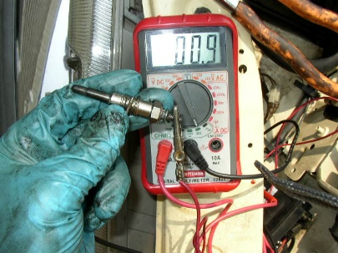
Replacing glow plugs
Indicative actions are:
- Remove any visible debris around the plugs which may fall into the cylinders – use of compressed air is recommended
- Disconnect the (negative) battery terminal
- Use a spanner to remove the nuts holding the bridging strap to the plugs
- Remove the bridging strap
- Use a spanner to untighten the glow plug and remove with fingers
- Test the new glow plug to be fitted
- Ensure plug and thread is clean
- Screw new plug in by hand until seated in cylinder head
- Tighten with torque wrench to torque specification according to the individual plug
- Replace bridging strap securing with nuts
- Re-connect battery
- Test.
For more information see:
https://www.youtube.com/watch?v=RCcmN-r5Z9M – Replacing glow plugs in a Mitsubishi Delica L400
https://www.youtube.com/watch?v=4Po_1pNHE1Y – Glow plug change
https://www.youtube.com/watch?v=4Po_1pNHE1Y – Easy and complete glow plug test.
http://autorepair.about.com/od/enginerelateddiyjobs/l/aa081404a.htm - How to replace your diesel glow plugs

Replacing mirrors
Indicative actions for replacing side mirrors are:
- If mirrors are simply attached by screws or bolts – remove the screws or bolts, remove the old mirror, locate the new part and re-attach the screws or bolts
- Where mirrors are fitted to the front frame (left or right-hand side) corner of the frame:
- Remove internal trim by gently levering cover away
- Where mirrors are powered there is a need to disconnect the battery and can be a need to remove inside door handles, trim panel and plastic cover/sheet – disconnect the wiring connector for the mirror
- Remove grummets and undo the bolts connecting the unit/mirror to the frame, supporting the mirror as this is done
- Remove the old unit
- Connect new unit fastening bolts and attaching wiring connector
- Replace trims, panels and items removed during disconnection
- Re-connect battery
- Test.
See also:
https://www.youtube.com/watch?v=U-1y8NIEhKM – Auto side mirror replacement
https://www.youtube.com/watch?v=77lBQ_CRqdo – Replace your passenger side mirror
https://www.youtube.com/watch?v=d8ASeN4rgek – Plastic backed mirror glass installation
https://www.youtube.com/watch?v=D6j8fwGCrHs – Side mirror glass replacement

Replacing coolant hoses

Steps are:
- Drain radiator – if necessary, using drain plug if fitted: there may be a requirement to retain the fluid to put back in the radiator
- Remove bottom radiator hose from radiator if there is no drain plug – use
- Ensure engine has cooled before removing radiator cap
- Use pliers to release clamp holding hose in place – at front and back of top and bottom hose (if changing both hoses)
It may be a good time to replace the thermostat while the top hose is off the vehicle
- Use flat screwdriver to help loosen connection and twist hose to break seal and remove the hose
- Clean the parts to which the hose ends were secured – to remove visible debris
- Determine if new hose clamps need to be used to fit the new hose/s – use new clamps where indicated
- Position clamps (using pliers to open them up) near end of new hoses and replace hoses
- Re-attach clamps
- Fill radiator
- Run and check for leaks.
Take the time to view:
https://www.youtube.com/watch?v=AGmQ50naiGg – How to replace a radiator hose (upper and lower)
https://www.youtube.com/watch?v=C64z0L9816A – Replacing radiator hose
https://www.youtube.com/watch?v=xH0D22ITjQU – How to replace the upper radiator hose

Changing tyres
See the videos at:
https://www.youtube.com/watch?v=fGp1meWKCD8 – How to change a tire
https://www.youtube.com/watch?v=joBmbh0AGSQ – How to change a tire: change a flat car tire step-by-step
https://www.youtube.com/watch?v=zspSsRGjLTw – How to change a tire
http://video.about.com/cars/Changing-Tires.htm - Video: tire change
http://video.about.com/cars/How-to-Change-a-Tire.htm - How to change a tire

Repairing punctures
Most operators have an SOP whereby all punctures are taken to a tyre dealership/garage to have them repaired.
Check the videos at:
https://www.youtube.com/watch?v=ulQmDaqv4F4 – Best tire repair video
https://www.youtube.com/watch?v=LRQJgTxRhOA – How to repair a puncture in a tyre with a repair plug/string
https://www.youtube.com/watch?v=tmW9YJpVwO4 – MSCTC Tire changing training video [using a commercial machine]
https://www.youtube.com/watch?v=2QR1vag1N9Q – Professional tire repair.
https://www.youtube.com/watch?v=wi5uBUaMsrA – How to repair a care or light truck tyre

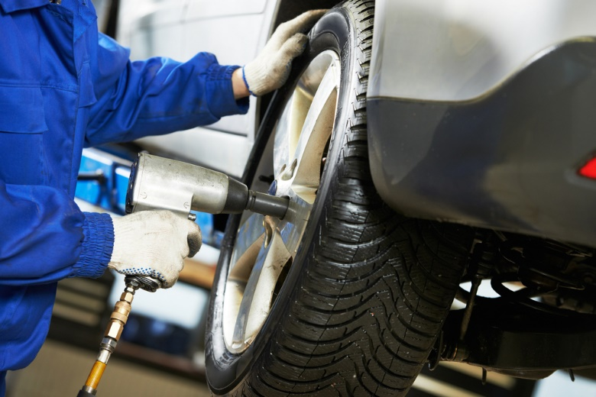

3.2 Use correct tools and follow manufacturer’s instructions

Introduction

Whenever repairs need to be made to vehicles there is a need to use the correct tools and follow manufacturer’s instructions.
This section looks at why this is standard practice and identifies examples of standard and purpose-specific tools which may be used by those maintaining and repairing vehicles.

Need to use correct tools and follow manufacturer’s instructions
It is important to use correct tools and follow manufacturer’s instructions in order to:
- Save time
- Save damage to the item being fitted and/or vehicle
- Reduce potential for personal injury
- Retain parts warranties and guarantees
- Optimise service life of part being fitted
- Ensure part integrates fully/properly with other items.

Examples of tools
A wide range of tools is available to service and repair vehicles – some are general in nature and some are specialist tools specific to certain jobs.
All the remaining information on tools in this section is used with permission and sourced from www.AutoUpkeep.com (Gray, M. E., & Gray, L. E.(2015, April 6). Basic Tools [Web page] Retrieved from http://www.autoupkeep.com/LCChapterTools.htm.
“Common Hand Tools
Common hand tools such as wrenches, ratchets, sockets, pliers, screwdrivers, hammers, and pry bars, are necessary when performing basic vehicle maintenance and repair work. You may find that you already own many of these tools.
Wrenches
Wrenches come in various sizes and designs. Adjustable, open-end, box-end, combination, and specialty wrenches are important tools to have when performing basic maintenance and repair. Both metric and standard (aka SAE) fixed jaw wrenches should be included in a basic tool kit.
Wrench Size
Metric sizes commonly increase by 1 millimetre (mm) for each wrench size increase. For example, a metric wrench set may have the following sizes: 7mm, 8mm, 9mm, 10mm, 11mm, 12mm, 13mm, 14mm, 15mm, etc. Standard wrenches commonly increase by 1/16” for each wrench size increase. Note: A quote mark ( ” ) is a symbol for inch units. For example, a standard wrench set may have these sizes: 1/4”, 5/16”, 3/8”, 7/16”, 1/2”, 9/16”, 5/8”, 11/16”, 3/4”, etc. The size corresponds to the distance between the two jaws in an open-end wrench.
Adjustable Wrench
An adjustable wrench is versatile. The jaw can be adjusted to fit metric or standard nuts and bolts. However, it does not fit as snugly on the fastener as a fixed sized jaw wrench. In addition, the head of an adjustable wrench may not fit in all locations and is not as strong. An adjustable wrench is sometime called a Crescent wrench (an industry brand name). If you are going to have only one wrench in your tool box, choose an adjustable wrench.
Combination Wrench
The two most common types of wrench ends are box and open. A combination wrench will have a box-end on one end and an open-end on the other. The box-end usually has 6-points or 12-points. Use the box-end 6-point when a great amount of torque is required to reduce the chance of stripping the fastener (i.e., a nut or bolt). An open-end is handy when the fastener position will not allow access with the box-end.
Ratchets
Ratchets in combination with sockets are used to quickly turn nuts and bolts. A ratchet is basically a lever with a pivoting mechanism. The pivoting mechanism allows the user to tighten or loosen a fastener without removing the tool. Ratchets are sized according to the square driver head. For example, 1/4” drive ratchets have driver heads that are 1/4” x 1/4”. Common ratchet sizes are 1/4”, 3/8”, and 1/2”. A 3/8” ratchet is the most common size that many do-it-yourselfers include in their basic tool kit.
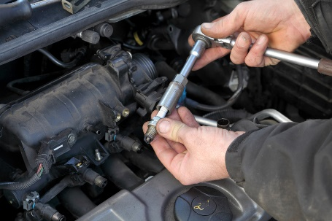
Standard Sockets
Sockets can be directly connected to the ratchet or first connected to a universal joint or driver extension. Sockets are classified as regular or deep well. Deep well sockets can fit over the threads of a long bolt. Sockets, like wrenches, have points inside that fit over the fastener and come in both metric and standard sizes. Common sockets will have either 6-points or 12-points.
Spark Plug Sockets
Some sockets are specially designed. For example, spark plug sockets have rubber boot inserts to protect the plug from cracking and to keep it centered.
Impact Sockets
Impact sockets should be used to avoid shattering standard sockets in situations where high torque and speed are needed, especially when using an electric or pneumatic (air powered) impact wrench. Impact sockets can be identified by their black colour and thicker sides.
Pliers
Pliers are handy adjustable tools that can be used in a variety of situations. Pliers are used to grab, turn, cut, or bend. Several types include: slip joint, locking, groove joint, needle nose, and diagonal cutters. Pliers consist of two levers that pivot at one point. This pivoting point is called a fulcrum.
Slip Joint Pliers
Slip joint pliers are one of the most basic and versatile hand tools. However, do not use slip joint pliers in situations where a wrench would be better (e.g., turning a nut or bolt). Trying to loosen a stubborn nut with slip joint pliers can strip the head or if the pliers slip, bruise your knuckles.
Locking Pliers
Locking pliers are sometimes called Vice-Grips, a brand name in the industry. Locking pliers are used to tightly grip and then lock on the fastener. These pliers come in handy when a bolt or nut is already stripped beyond the point where a wrench no longer works. Grabbing onto flat pieces of metal or oddly shaped items are additional functions of locking pliers.
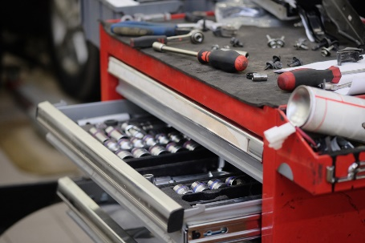
Groove Joint Pliers
Also called adjustable pliers or Channellocks (an industry brand name), groove joint pliers adjust to a wide range of sizes. These are especially useful for gripping cylindrical objects, like pipes.
Needle Nose Pliers
Needle nose pliers have long pointed jaws. These can be used to grip or pull objects that are in hard-to-reach areas. Next to the fulcrum is also a cutting mechanism to cut wire or other objects.
Diagonal Cutting Pliers
Also called side cutters, diagonal cutters have sharp cutters instead of gripping jaws like most pliers. They are commonly used for cutting wires.
Screwdrivers
Just about everyone is familiar with screwdrivers. They turn screws or other fasteners. Some screwdrivers have magnetic tips to help with positioning fasteners in tight spaces. The head of a fastener determines the type and size of screwdriver tip that is needed. The proper tip will fit in a fastener head snugly. Damage or tool slippage may occur if an incorrect sized tip is used. Common types of screwdriver tips include Phillips, slotted, square, Allen, Torx, and hex. Various types of screwdriver tips are also made as bits that can be placed in a 1/4” socket for ratcheting in tight places.
Hammers
Sometimes what you are working on needs a little more persuasion. Using the correct hammer will ensure that you don’t damage components. A ball peen hammer, a favourite hammer by many technicians, is commonly used to drive a chisel or a punch. A rubber mallet, a hammer with a rubber head, comes in handy to drive on stubborn wheel covers and other parts without damaging them.
Pry Bars
Pry bars are long bars with handles that come in a variety of sizes and styles. They can be useful when trying to leverage a component that is heavy or stuck.
Lifting Tools
When performing work under a vehicle it is often necessary and convenient to raise the vehicle off the ground with a floor jack and jack stands or drive-on ramps. Work safely by using lifting equipment on a surface that is solid and chock at least one wheel still on the ground. Warning: Lifting equipment ratings should exceed the weight of the vehicle being lifted.
Floor Jack
A floor jack is used to lift a vehicle. Be sure to place the jack’s lifting pad under the frame or other solid chassis component. Lifting the vehicle by the body’s sheet metal underbody will damage the vehicle and make it more likely to fall off the jack. Warning: To prevent serious injury or death jack stands should be used. Do not go under a vehicle that is only supported by a jack.
Ramps
Drive-on ramps can make raising one end of your vehicle very easy. All you need to do is line the ramps up in front of your tires, drive onto them, set your emergency brake, and chock one wheel remaining on the ground. Since the vehicle is still resting on its tires, don’t plan on doing any wheel work. Ramps are convenient for oil changes and undercarriage inspections.

Wheel Chocks
To prevent a vehicle from moving forward or backward, wheel chocks are used to block a wheel when jacking. Place the wheel chocks in front and in back of a wheel that is not being lifted.
Jack Stands
Jack stands are used to hold a vehicle up after a jack has raised it. Warning: Do not use concrete blocks or other non-approved stands to hold up a vehicle.
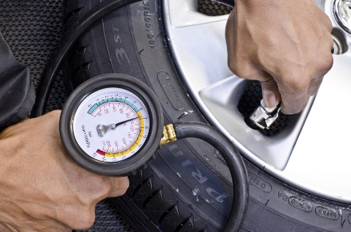
Tire Tools
Tire Pressure Gauges
Tire pressure is measured with tire pressure gauges and should be checked often. A dial gauge is more accurate than a stick gauge. A recommended tire pressure is calculated according to the tire type, vehicle weight, and the desired ride. Look in your driver’s side door for a tire placard that lists the correct tire pressure. Maintaining the recommended tire pressure is critical to minimizing tire wear and optimizing handling stability. For every 10 degrees temperature drop, tire pressure drops by 1 psi. The inverse also occurs as temperature rises.
Tread Depth Gauge
A tread depth gauge is a simple measuring devise to help determine the actual amount of tread remaining on your tires. It provides a depth reading within 1/32nd’s of an inch from the top of the tread surface to the bottom of the tread groove. When that reading is less than 1/16th of an inch, new tires are needed.
Tire Plug Tools
Tire plug tools make it possible to plug holes smaller than 1/4” in diameter in the tread of a tire without taking the tire off the rim. The plug rasp tool prepares the hole for the plug and the insert tool installs the plug.
Bottle and Scissor Jacks
Most newer vehicles have a scissor or bottle jack stored in the trunk for emergency tire changes. These manufacturer supplied jacks are not as easy or as safe to use as a hydraulic floor jack. Save them for roadside emergencies and invest in a hydraulic jack for your garage.
4-Way Tire Tool
A 4-way tire tool is more versatile for removing lug nuts than the basic manufacturer lug wrench (aka tire iron) supplied with your vehicle. A 4-way has a different sized wrench on each end. It is also easier to use because the design provides more leverage and you can spin the lug nuts off quicker.
Measuring Tools
Measuring accurately requires the use of measuring tools like rulers, gauges, and micrometers. In the United States two systems of measurement are often used: the metric (aka international) system and the English (aka customary) system.
Rulers
Rulers are used to measure linear distances. Measuring tapes are used to measure large distances whereas small rigid rulers are used to measure short linear distances.

Torque Wrench
A torque wrench, either beam or clicker style, can be used to tighten a fastener to a specific amount of force. For example, wheel lug nuts should be tightened to the manufacturer’s specifications. Lug nuts that are not tight enough could loosen over time, while lug nuts that are too tight are hard to remove, can warp brake rotors, and can damage the stud’s threads. A torque wrench is critically important when completing internal engine repairs.
Coolant Tester
A coolant tester measures specific gravity to determine if the cooling system contains the correct mixture of antifreeze to water. To draw coolant up into the tester, squeeze the bulb while the tube end is inserted in the radiator. An indicator inside the tester floats to give a reading based on the percentage of antifreeze in the coolant.
Spark Plug Gauge
A spark plug gauge tool has various diameter wires for checking the electrode gap and benders to adjust the gap. The gap is the distance between the centre and side electrodes on the spark plug. A spark must arc across the gap in order to ignite the air-fuel mixture in a cylinder. The correct gap is located on the EPA sticker in the engine compartment.
Precision Measuring Tools
Feeler gauges, callipers, micrometres, and dial indicators are used to obtain very precise measurements. These tools can provide measurements to the nearest thousandths (0.001) of an inch or to the nearest hundredths (0.01) of a millimetre. Feeler gauges consist of flat metal blades that are a specific thickness. You can put several feeler blades together to obtain a desired thickness. For example, if you needed to obtain a thickness of 0.045”, you could put the 0.025” and 0.020” together. A calliper is an especially versatile measuring tool able to measure inside, outside, and depth dimensions. However, when extremely precise measurements are required consider using a micrometer. Micrometers are particularly good for measuring the diameter of objects.
Electric Tools
If you plan to maintain a vehicle’s electrical system some electrical tools will be necessary. At the very least every vehicle should carry a set of jumper cables.
Multimeters
Multimeters make a great addition to any toolbox. Multimeters can be used to measure voltage, resistance, and amperage.
Fuse Puller
Fuses are fairly small, very close to one another in a fuse junction block, and often tightly held making it difficult to pull them out. A fuse puller is a small plastic device designed to grasp a fuse so it can be pulled out easily.
Wire Strippers
Wire strippers can be used to remove wire insulation, cut wires, and to crimp solder less connectors and terminals.
Battery Load Tester
A battery load tester is a specialty tool used to evaluate a battery’s condition. The tester should be set to the battery’s temperature and cold-cranking amperage (CCA) rating to receive accurate results. Note: Some automotive part stores will test your battery for free.
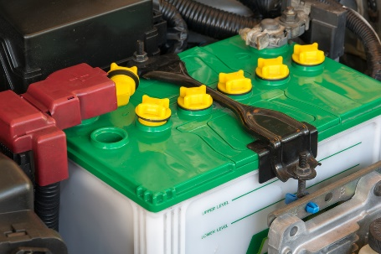
Jumper Cables
A battery can discharge simply by leaving your lights on or a door ajar. You should know how to properly hook up jumper cables in case of an emergency. For step-by-step procedures on safely hooking up jumper cables see your owner’s manual and the Jump-Starting Activity. Warning: Incorrectly jump-starting a battery can be dangerous. If cables are hooked up incorrectly the battery could explode or electrical components could fry.
Battery Terminal Puller
The battery terminal puller is designed to remove a stubborn or corroded battery terminal clamp, after the battery terminal nut has been loosened, without causing damage to the battery terminal post. The lower jaws of the puller are placed under the battery terminal clamp and then the top lever is turned to lower the centre screw onto the terminal post until it forces the clamp free. This type of puller is only used on top post batteries.
Battery Brush
Once the battery terminal clamps have been disconnected from the battery posts, use battery brushes to scrape off any visible white or light colored corrosive powder. Rotate the external wire battery brush inside each clamp and the internal wire battery brush over each post.
Battery Terminal Spreader
The battery terminal spreader is specially designed to spread battery terminal post clamps. They can also be used to scrape corrosion from the inside of terminal clamps.
Oil Change and Lube Tools
To perform an oil change and lubrication you will need a socket or wrench to remove the drain plug, lifting equipment, an oil drain pan, an oil filter wrench, a funnel, and a grease gun.
Oil Drain Pan
An oil drain pan helps to keep used oil from spilling on the floor. A good oil pan will have a wide collection area, a place for the oil filter to set while draining, enough capacity to hold at least one oil change, and a cap to prevent spilling during transportation to an oil recycling facility. Used oil is considered a hazardous waste.


Oil Filter Wrenches
There are mainly two styles of oil filter wrenches. The band filter wrench is made to adjust to several different sized filters within a range; for hard to reach filters get a filter wrench with a swivel handle. The cup oil filter wrench is used with a ratchet for leverage. Select the cup size that fits snugly on your filter.
Funnel
A funnel helps prevent spills when adding oil to the engine. Always make sure the funnel is clean so you don’t contaminate the engine with other fluids or dirt.
Grease Gun
A grease gun, containing a grease cartridge, is used to lubricate steering, suspension, and drivetrain components. A vehicle’s service manual should identify the location of lubrication fittings (if there are any) and the type of grease recommended. As technology advances more automotive parts are being manufactured with a permanent seal, so grease can’t be added.
Cutting and Grinding Tools
Sometimes it is necessary to remove a piece of metal such as an exhaust pipe or a rusted bolt. To do this, cutting and grinding tools come in handy.
Hacksaw
Hacksaws cut metal using thin blades. Blades commonly have 18, 24, or 32 teeth per inch. Blades with more teeth per inch cut cleaner and slower. Point the teeth away from the handle to cut mainly on the forward stroke.
File
A file can be used to smooth, shape, and de-burr surfaces by removing metal. Common machinist files come in square, flat, half-round, and round types.
Chisel
To use a cold chisel place the chiselled end on an object, such as a seized/rusted nut or rivet, and hit the blunt end with a hammer.
Punch
Punches can be used to drive parts during removal or installation, mark points, or align objects. To use a punch, place the pointed end on the object you want to drive and hit the blunt end with a hammer.
Grinder
An electric grinder can be used to remove metal much faster than a file. Warning: Grinding metal can create sparks. Be sure that all flammable materials are away from the grinding area and do not grind so that sparks go near the vehicle’s fuel tank. It is also important to wear the appropriate safety gear, including a full face shield.”

3.3 Make arrangements for external repair provision where requirements cannot be accommodated internally

Introduction

Where vehicles cannot be fixed within the organisation there is a need to arrange for them to be externally repaired.
This section (which reinforces much of the information presented in section 1.16) identifies factors to consider in the process and presents steps which are usually.

Factors to consider
Issues which can influence the need to take a vehicle to an external repairer for work may include:
- Extent of work which needs to be done – smaller jobs may be handled internally but larger jobs tend to be sent out
- Timeframes which apply – where there is a definite or tight timeline for the completion of work, it can be better to have the work done by a professional
- Safety issues – anything which relates to matters of safety tends to be undertaken by suitably qualified technicians and service people so as to discharge the common law Duty of Care imposed on businesses
- Complexity of the job – simple jobs may be done in-house but the more difficult work tends to be outsourced
- Tools and equipment available – where specialist tools and equipment are required for work it can be more economical to get outside businesses to do the job
- Expertise – there will just be some jobs where organisational personnel have no experience and no real idea of what to do so there is an obvious imperative for the work to be done by experienced professionals
- Terms of warranties and guarantees – in order to maintain the protection/coverage provided by some warranties and guarantees there can be a need for specified work to be done by ‘authorised dealers or agents’.

Steps in the process
When making arrangements for work to be done on vehicles by an external provider, the following may be required:
- Notify management or administration – and:
- Advise them of the situation and the reason for external service provision
- Discuss known details of the work required
- Give an estimate of cost, if known
- Identify urgency of work that needs to be done
- Tell them of any bookings/identified up-coming use for the vehicle
- Determine if quotations are required – and if so, how many
- Seek and obtain formal approval to proceed
- Identify the relevant repairer/s – this may be:
- The organisation from which the vehicle was purchased
- The authorised dealer for the make
- The preferred service provider as determined by the business
- An approved repairer as designated by a recognised motoring body or insurer
- Speak to the selected provider/s by phone or in person – and:
- Advise of the nature and extent of work required
- Explain urgency of work required and need for vehicle to be returned to service by given date, if applicable
- Take the vehicle in to the business, if possible or required – for them to see/inspect
- Request quotation for the work to be done – if necessary
- Schedule the work – to:
- Best integrate repairs with any other work to be done – so as to minimise down-time
- Maintain vehicle ‘in service’ for maximum time – providing it is safe to do so
- Make a booking for the work to be done – with the chosen provider which may be chosen based on:
- Quotation received
- Ability to perform the work by required date
- Previous experience with the business
- Direction from management, warranty/guarantee or insurer
- Take necessary other action – which may entail:
- Ensuring vehicle is not used until the required repairs have been completed, where safety is a concern
- Re-arranging vehicle usage sheets to accommodate absence of the vehicle
- Hiring/renting another vehicle to replace the one being repaired
- Advising known vehicle users of changes made.


3.4 Comply with mandated safety requirements while undertaking repairs

Introduction

It is as critical to comply with mandated safety requirements when undertaking vehicle repairs as it is when performing vehicle service.
This section re-presents information from section 1.17, discusses safety signage, addresses the need to follow manufacturer’s instructions, and looks at safe handling of chemicals.

Basic safety requirements
When maintaining and repairing vehicles:
- Taking responsibility for personal safety – people must take responsibility for their own safety regardless of all other protocols which are in place
- Being alert to the possibility of risk – due to faulty equipment, risky practice, introduction of a new product or procedure into the workplace: being aware the workplace is a dangerous environment and has the potential to cause injury is the biggest, single factor in taking the initiative for safety at work
- Warning others of hazards – so they avoid them
- Learning workplace safety policies and procedures – what applied at a previous workplace may not apply at the current workplace
- Understanding a hazard can exist today that did not exist yesterday – due to the dynamic nature of work
- Realising a remedy for one workplace risk can introduce a new/other workplace hazard
- Reporting any workplace risk/hazard – as soon as it is identified
- Keeping the work area neat and tidy – as this helps create a safety-oriented mind set: there seem to be fewer accidents and injuries in neat and clean workplaces
- Wearing clothes that are fit for the job – no hanging threads, loose sleeves: wear/provide safe and comfortable clothes
- Reporting ‘near misses’ as well as actual accidents/injury – so investigation and preventative action can be taken
- Looking out for the safety of others – other staff and members of the public
- Immediately ceasing any work as soon as it becomes dangerous – rather than ‘pressing on’ in dangerous conditions
- Participating in workplace safety discussions, inspections, feedback and management – so workplace safety is consultative
- Adhering to SOPs, SWPs and manufacturer’s instructions – as these have been developed with safety in mind
- Wearing/using designated PPE as directed – such as eye protection, gloves, steel-capped boots
- Using all appliances, equipment, tools as directed – making sure the right tool is used for the right job
- Intervening when a dangerous workplace situation is identified – to protect people/others against injury
- Taking care when working, which includes:
- Not rushing
- Thinking about what needs to be done
- Thinking about how to do what needs to be done
- Not doing anything believed to be unsafe
- Taking practical action when required, such as:
- Picking up items from the floor when they have been dropped
- Cleaning up spills immediately – instead of ignoring them or leaving them for someone else to do
- Disposing of glass (including broken glass) into designated containers
- Undertaking a first aid course – so help can be provided if necessary
- Being trained in workplace health and safety – as it applies to the workplace, and attending all workplace-based health, safety and welfare training
- Not working when unfit to do so – as a result of tiredness, injury, other causes
- Seeking to establish a safe place/working environment – rather than relying on employees working in a safe manner
- Applying safe manual handling protocols – in relation to moving and lifting objects in the workplace
- Ensuring there are MSDS for all chemicals used in the workplace – and they are readily available to workers
- Handling chemicals according to established safe chemical handling, storing and usage protocols – as developed by the organisation for the chemicals used within the business
- Abiding by the requirements of health, safety and welfare legislation – as it applies locally/nationally
- Including health and safety training as part of the Induction and Orientation – for all new employees
- Following manufacturer’s instructions – when using tools and equipment and when maintaining and repairing vehicles
- Ensuring a fire extinguisher is close-by – just in case it is needed.


Safety signs
There is a need to provide, understand and abide by safety signage in the workplace.
Safety signs are usually international in shape and colour:
- A red circle with a diagonal line indicates ’No’/’Do Not ... Smoke/Enter’
- Blue indicates something must be done – such as wear hearing protection, boots, safety glasses
- Yellow/orange is used for warning signs – be aware that …
- Green is used for assistance and directional signage – showing the location of First Aid, Emergency exits
- All red signs indicate fire equipment/exits.
Stop  Prohibition signs  You must not  Do not  Stop. |  |  |  | 
Danger  Caution  Risk or danger  Hazard controls. |  |  |  | 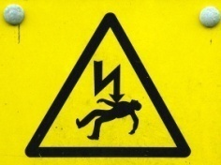
Safety  Safe condition and first aid sign  Safe way  First aid equipment  Where to go in an emergency. |  |  |  | 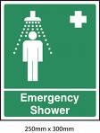
Fire  Fire signs  Location of firefighting equipment. |  | 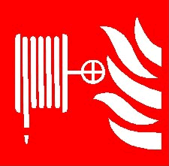 | 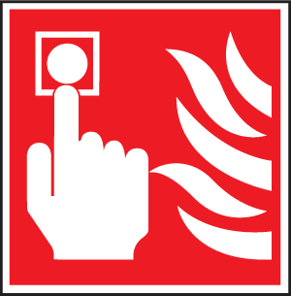 | 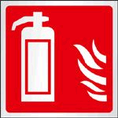

Following manufacturer’s instructions
Importance of following manufacturer’s instructions
All items used in the workplace (for repairs and service) must be used and maintained in accordance with manufacturer’s instructions so that:
- Safety to the user (and others) is optimised
- Damage is avoided – to the equipment itself and the item it is being used on/with
- Guarantees and warranties are preserved – failure to follow manufacturer’s instructions will commonly void these
- Optimum results are achieved – manufacturer’s instructions will mostly lead to the best job being done (in terms of cost, efficiency, end result).
Times at which ‘manufacturer’s instructions’ apply
Commonly there is a need to comply with manufacturer’s instructions:
- Prior to using the item – to:
- Check it is safe to use
- Verify all parts of the item are present
- When actually using the equipment for its intended purposes – by ensuring workers:
- Do not exceed load levels, pressures, speed, temperature, run times etc
- Never use the item for a task it was not intended/designed for
- Use/wear the necessary PPE – where/if applicable
- Use the correct attachments/tools for the different actions the equipment is being asked to perform
- After using the equipment – by:
- Cleaning the item as required
- Storing/stowing the equipment
- Maintaining the equipment – by:
- Providing service as set out in the instructions
- Changing/replacing parts (filters, O-rings, springs, spacers and other components as identified) at designated times
- Only having repairs to nominated tools and equipment undertaken by qualified and authorised service technicians
- Using only genuine parts for service.

Keys in following manufacturer’s instructions

The following will assist the safe use of equipment in accordance with manufacturer’s instructions:
- Obtain a copy of the manufacturer’s instructions – by:
- Contacting supervisor and requesting a copy
- Talking to the Purchasing Officer at the workplace – they often remove instructions from the item when it is delivered and keep them on file for future reference
- Speaking to the training department – as they often have these instructions for training purposes
- Contacting the manufacturer and asking for a copy – ring the supplier, or speak to the representative and ask them to forward a copy
- Going on the internet and visiting the website of the manufacturer – many businesses provide operating instructions for free download
- Looking on the intranet – the employer may have loaded the instructions onto a section called ‘Manufacturer’s instructions’
- Photocopy the instructions so there is a spare copy
- Read the instructions – and ensure understanding of them: ask questions where necessary to clarify ambiguities
- Use equipment as instructed – which means avoiding taking short-cuts and/or avoiding the belief a better way of doing things has been found
- Stop using the item immediately a problem has been detected – unusual vibration, strange smell, different noise.

Chemicals
Globally Harmonised System of Classification and Labelling of Chemicals (GHS)
Background
The Globally Harmonised System of Classification and Labelling of Chemicals (GHS) is a United Nations (UN)-developed system for chemical classification and hazard communication through harmonized provisions for standardized labels and safety data sheets (SDS). It is developed from various existing systems in the US, EU, Canada, and from the UN’s own research and study of universal standards.
The GHS was endorsed by the UN World Summit for Sustainable Development in 2002. At the 14th APEC Ministerial Meeting in Oct 2002, APEC Trade Ministers also set its stamp of approval on the GHS for APEC-wide implementation by 2006. This target date was rescheduled to 2008 at the APEC Chemical Dialogue meeting in 2006.
The status of GHS implementation in 67 countries is listed here-http://www.unece.org/trans/danger/publi/ghs/implementation_e.html.
GHS in a Nut Shell
The GHS is documented in the UN publication - GHS Document (commonly known as the “Purple Book”). The full text of the system is available here-http://www.unece.org/trans/danger/publi/ghs/ghs_rev03/03files_e.html.
The GHS is essentially a hazard communication system for identifying and conveying chemical hazards, and for providing information related to chemical hazards and their control and prevention.
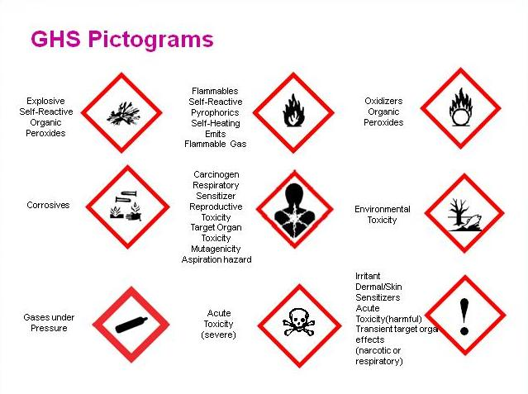
The GHS requires chemicals to be classified based on their inherent properties or hazards and in accordance with certain classification criteria. The classified chemicals are assigned to a fixed set of GHS pictogram(s), signal word, hazard and precautionary statements.
The GHS also requires SDS [Safety Data Sheets] to be prepared for all classified hazardous chemicals in accordance with a standardized format.
Information provided on the labels and SDS enables users of hazardous chemicals to identify the hazards and take the necessary preventive or protective measures for their health and safety.

Work Projects
It is a requirement of this Unit you complete Work Projects as advised by your Trainer. You must submit documentation, suitable evidence or other relevant proof of completion of the project to your Trainer by the agreed date.
3.1 To fulfil the requirements of this Work Project you are required to undertake minor repairs to vehicles approved by your Trainer/Assessor providing evidence you have:
- Removed, repaired and/or refitted vehicle components
- Used correct tools and follow manufacturer’s instructions
- Made arrangements for external repair provision where requirements cannot be accommodated internally
- Complied with mandated safety requirements while undertaking repairs.

Summary

Undertake minor repairs to vehicles
When undertaking minor repairs to vehicles:
- Take care not to void warranties
- Refer to owner/workshop manuals for direction and advice
- Obtain the required parts before starting the job
- Obtain and use the right tools for the job
- Work safely
- Check for other problems with the vehicle at the site where work is being done
- Perform basic repairs on-site where possible and practicable
- Arrange for external repairs where matters cannot be resolved internally.

Element 4:
Complete documentation

4.1 Ensure vehicle inspection checklists are completed

Introduction
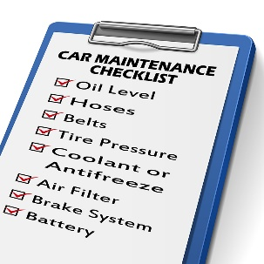
A standard requirement among tour operators is the need for specified documentation to be completed as required.
This section details generic actions for completing vehicle inspection checklists.

Completing vehicle inspection checklists
Standard practice for completing vehicle inspection checklists are:
- Obtain the necessary checklist – there may be different checklists for different types of vehicles, based on factors such as makes, models, carrying capacity, vehicle configuration or registration number
Other operators may use a generic inspection checklist where users are required to enter relevant details (registration number, make and model) to identify the vehicle being inspected
Checklists also exist for trailers
- Carry and use the checklist while inspecting the vehicle – do not inspect the vehicle and rely on memory to fill in the form
- Undertake the inspection at the required times – which may be:
- Before a vehicle departs for a tour
- Every morning before a vehicle is used while on tour
- Weekly for office vehicles
- Inspect the vehicle in the sequence of the checks listed on the checklist – the items to be checked should be listed in a logical and sequential manner that:
- Facilitates an ordered/structured inspection
- Minimises the amount of time needed to do the inspection
- Undertake all the listed inspections – never skip any of them
- Inspect the vehicle in the ways required by the checklist – which may be:
- Stationary and not running
- Stationary and running
- Operating/moving
- Tick off the items () as they are inspected – to show they have been checked and are acceptable/OK
- Place a cross (X) in the tick boxes where a problem is identified – and add some written comment:
- Explaining/describing the problem
- Identifying the urgency of the need for maintenance or repairs
- Being honest and accurate in the responses and information provided/written down
- Place unsafe/un-roadworthy vehicles out-of-service – so they cannot be used
- Write down the odometer reading – this is a standard requirement for most vehicle checklists
- Date the completed checklist – to give a point of reference
- Sign the form (there may also be a need to print name) – so others know who did the inspection
- Process the completed form – which may involve:
- Forwarding the form to the nominated person or department so it can be auctioned as needed according to internal protocols 9where maintenance or repairs are necessary)
- Arranging repairs and service by external businesses – where the problems cannot be fixed internally
- Filing the form for future reference
- Using/providing/accessing the form when work needs to be performed on the vehicle.
Websites
See the following as examples of what may be used and required:
http://www.atyourbusiness.com/vehicleinspection.php - Sample vehicle inspection report forms
www.adtasa.com.au/forms/Vehicle_checklist_2011.doc - Vehicle inspection checklist
http://www.ehs.gatech.edu/general/weekly_vehicle_inspection_checklist.pdf - Weekly motor vehicle inspection checklist.
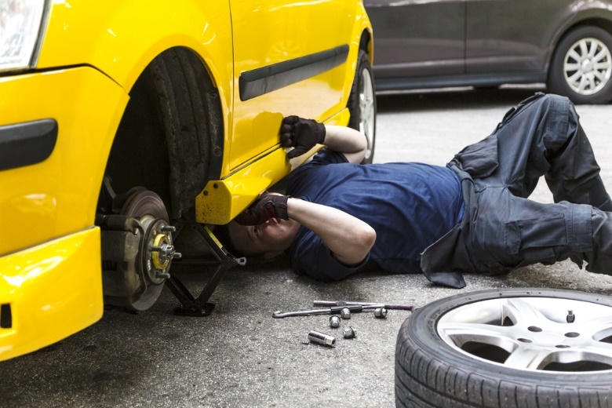

4.2 Complete internal documents to record provision of service and repairs

Introduction

It may be SOP for all work done on vehicles to be recorded.
This section identifies points to note when documenting in-house repairs and maintenance performed on vehicles.

Completing the internal documents
Standard practice as part of the process for providing service and repairs to organisational vehicles is to complete a ‘Service Report’ form/log or similar.
Completing this documentation includes:
- Using the approved template/form – where businesses require this information to be recorded they will provide a document especially for the purpose
The document is commonly hard copy but may be electronic
- Identifying the vehicle which has been serviced/repaired – as required by the business, which require:
- Registration number
- Make and model
- Odometer reading
- Completing the form immediately after the work has been completed – or as the work progresses, rather than the next day or at the end of the week
- Describing service and repairs provided – in sufficient detail to allow others to interpret and understand the work that was undertaken
Keys are:
- Write clearly
- Be honest
- Cover all work done
- Use recognised abbreviations and acronyms
- Cross-reference to parts used
- Noting matters that will/may require attention at the next service – so that:
- Vehicle users/operators are aware of this – and can factor it into their use of the vehicle
- Management/administration are made aware of significant/costly issues which are imminent
- Necessary resources, parts and other requirements are purchased/obtained in advance of the next scheduled service session

- Recording the action taken for cost and stock control purposes – which may require:
- Listing items used – parts and fluids
- Costing each unit/item
- Including hours spent on the job
- Calculating totals – for parts and labour involved in service and/or repair provision
- Updating next scheduled service for the vehicle – in terms of (as appropriate):
- Date when service is required
- Odometer reading when service is required.
This update might be required:
- in a central Service Index – kept to monitor service dates for all vehicles
- In the manual for the vehicle – kept in the glove box/similar in the vehicle
- On a sticker placed on the windscreen of the vehicle
- Attaching the inspection checklist (or copy) which initiated/triggered the work to the completed ‘Service Report’ – if required
- Returning the vehicle to its normal location – to return it to service
- Notifying personnel who may be waiting on the vehicle – that it is now ready
- Processing paperwork – forwarding it as required to administration/management.
Websites
See:
download.microsoft.com/download/9/d/c/.../Vehicle_Repair_Log.xlt – Vehicle repair log
http://www.vertex42.com/ExcelTemplates/vehicle-maintenance-log.html - Vehicle maintenance log.
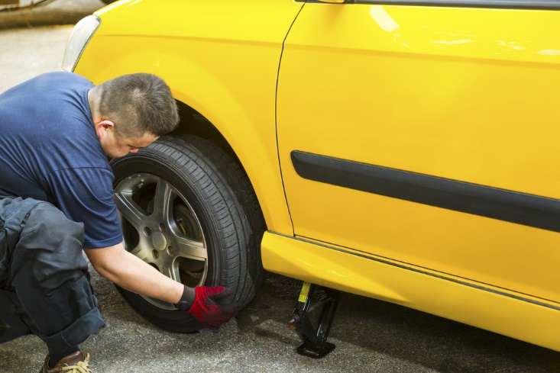

4.3 Adhere to requirements in relation to the completion and maintenance of vehicle service and repair documentation

Introduction

In addition to the requirements detailed in the previous section there can be other obligations to document repairs and maintenance performed on vehicles.
This section identifies requirements which may need to be complied with in this regard.

Need for recording action taken
The need to record the completion and maintenance of vehicle service and repairs may include:
- A range of host enterprise requirements - which can relate to:
- Monitoring costs
- Tracking vehicle use
- Identifying vehicle service dates
- Identifying vehicle dates
- Calculating economy
- Need to comply with legislated requirements – especially:
- Vehicle registration in the correct (‘commercial’) category
- Mandatory insurance
- Roadworthiness
- Requirements imposed on the business by clients such as tour operators, venues and site operators who contract the use of vehicles – as these apply to:
- Cleaning of vehicles ready for use
- Maintaining service of vehicles for operational reliability and safety
- Ensuring availability of vehicle at times they are required/booked/contracted
- Recording use by external parties
- Capturing usage facts for administration and charging purposes
- Requirements imposed on the business by third parties such as insurers and auditors – such as:
- Advising of incidents and accidents, as/if necessary
- Notifying of repairs and/or modifications
- Maintaining insurance coverage
- Ensuring vehicles are maintained in a condition (operational, appearance, comfort, safety, facilities) that complies with the standard demanded by the code/system being audited
- Requirements imposed by the Taxation agency for the country – in terms of:
- Maintaining records to show usage information of the vehicle/distance travelled and other data as may be required to demonstrate legitimate business-related use – for example:
  - Times and dates
  - Destinations
  - Purpose/reason for travel
  - Retaining evidence/receipts of work performed on vehicle and fuel for it.

Work Projects
It is a requirement of this Unit you complete Work Projects as advised by your Trainer. You must submit documentation, suitable evidence or other relevant proof of completion of the project to your Trainer by the agreed date.
4.1 To fulfil the requirements of this Work Project you are required to complete documentation related to vehicle inspections, service and repair providing evidence you have:
- Ensured vehicle inspection checklists are completed, dated, signed and filed
- Completed internal documents to record provision of service and repairs
- Adhered to requirements in relation to the completion and maintenance of vehicle service and repair documentation.

Summary

Complete documentation
When completing documentation:
- Fill in vehicle inspection checklists as and when required
- Date and sign documentation
- Ensure all required information is provided and sufficient detail is recorded
- Fill in internal documentation to record and describe service and repairs performed on vehicles
- List resources used when servicing and repairing vehicles
- Identify issues needing attention in the future as part of the document completion process
- Up-date scheduled servicing records following completion of a service
- Comply with externally-imposed compliance requirements.

Presentation of written work

Introduction
It is important for students to present carefully prepared written work. Written presentation in industry must be professional in appearance and accurate in content. If students develop good writing skills whilst studying, they are able to easily transfer those skills to the workplace.

Style

Students should write in a style that is simple and concise. Short sentences and paragraphs are easier to read and understand. It helps to write a plan and at least one draft of the written work so that the final product will be well organised. The points presented will then follow a logical sequence and be relevant. Students should frequently refer to the question asked, to keep ‘on track’. Teachers recognise and are critical of work that does not answer the question, or is ‘padded’ with irrelevant material. In summary, remember to:
- Plan ahead
- Be clear and concise
- Answer the question
- Proofread the final draft.

Presenting Written Work
Types of written work
Students may be asked to write:
- Short and long reports
- Essays
- Records of interviews
- Questionnaires
- Business letters
- Resumes.
Format
All written work should be presented on A4 paper, single-sided with a left-hand margin. If work is word-processed, one-and-a-half or double spacing should be used. Handwritten work must be legible and should also be well spaced to allow for ease of reading. New paragraphs should not be indented but should be separated by a space. Pages must be numbered. If headings are also to be numbered, students should use a logical and sequential system of numbering.
Cover Sheet
All written work should be submitted with a cover sheet stapled to the front that contains:
- The student’s name and student number
- The name of the class/unit
- The due date of the work
- The title of the work
- The teacher’s name
- A signed declaration that the work does not involve plagiarism.
Keeping a Copy
Students must keep a copy of the written work in case it is lost. This rarely happens but it can be disastrous if a copy has not been kept.
Inclusive language
This means language that includes every section of the population. For instance, if a student were to write ‘A nurse is responsible for the patients in her care at all times’ it would be implying that all nurses are female and would be excluding male nurses.
Examples of appropriate language are shown on the right:
Mankind | Humankind
Barman/maid | Bar attendant
Host/hostess | Host
Waiter/waitress | Waiter or waiting staff

Recommended reading
Note: all Recommended Reading is sourced from ‘Trove: National Library of Australia’ at http://trove.nla.gov.au/.

Duffy, James E 2015, Auto engine repair, 6th edition, Tinley Park, Illinois Goodheart-Willcox Company, Inc
Duffy, James E 2015, Auto electricity and electronics, Sixth Edition, Tinley Park, Illinois Goodheart-Willcox Company
ERJAVEC, JACK 2015, Manual transmissions and transaxles: Classroom manual + shop manual, Cengage learning
GILLES, TIM 2015, Automotive engines: Diagnosis, repair, rebuilding, Delmar Cengage learning
HADFIELD, CHRIS 2016, Basic automotive service & systems, Cengage learning, Boston
Halderman, James D 2016, Automotive technology: principles, diagnosis, and service, Fifth edition, Boston Pearson
Halderman, James D 2015, Automotive engines: theory and servicing, Eighth edition, Boston Pearson
HALDERMAN, JAMES D 2015, Automotive steering, suspension & alignment, Prentice Hall, Upper Saddle River
Seymour, Brendan, (editor.) & Rooth, John, (editor.) & Cahill, Graham, (editor.) 2015, Roothy's ultimate 4WDing guide, EMG Express Media Group, Silverwater, N.S.W
Stockel, Martin W & Stockel, Martin T & Johanson, Chris 2015, Auto fundamentals : how and why of the design, construction, and operation of automobiles : applicable to all makes and models, 11th edition, Tinley Park, IL The Goodheart-Willcox Company, Inc
Strachan, Jack 2004, Fix your car: how to carry out your car repairs like a professional, Ivy Press, Lewes, East Sussex
VanGelder, Kirk T 2015, Fundamentals of automotive maintenance and light repair, First edition, Burlington, MA Jones & Bartlett Learning.

Trainee evaluation sheet

Carry out vehicle maintenance or minor repairs
The following statements are about the competency you have just completed.
Please tick the appropriate box | Agree | Don’t Know | Do Not Agree | Does Not Apply
There was too much in this competency to cover without rushing.
Most of the competency seemed relevant to me.
The competency was at the right level for me.
I got enough help from my trainer.
The amount of activities was sufficient.
The competency allowed me to use my own initiative.
My training was well-organised.
My trainer had time to answer my questions.
I understood how I was going to be assessed.
I was given enough time to practice.
My trainer feedback was useful.
Enough equipment was available and it worked well.
The activities were too hard for me.

The best things about this unit were:

The worst things about this unit were:

The things you should change in this unit are:

Trainee self-assessment checklist
As an indicator to your Trainer/Assessor of your readiness for assessment in this unit please complete the following and hand to your Trainer/Assessor.

Carry out vehicle maintenance or minor repairs
 |  | Yes | No*
Element 1: Provide scheduled service to vehicles
1.1 | Identify necessary minor servicing requirements for specific vehicles
1.2 | Determine situations in which maintenance may need to be carried out
1.3 | Undertake visual inspections of the vehicle
1.4 | Check and adjust vehicle structure
1.5 | Check and adjust lighting
1.6 | Check and adjust vision-related items
1.7 | Check and adjust entrances and exits
1.8 | Check and adjust vehicle interior
1.9 | Check and adjust brakes
1.10 | Check and adjust steering
Element 2: Diagnose minor vehicle faults
2.1 | Identify minor faults
2.2 | Determine cause of faults
2.3 | Error! Reference source not found.
2.4 | Error! Reference source not found.
2.5 | Error! Reference source not found.
2.6 | Error! Reference source not found.
2.7 | Error! Reference source not found.
2.8 | Error! Reference source not found.
2.9 | Error! Reference source not found.
2.10 | Error! Reference source not found.
Element 3: Undertake minor repairs to vehicles
3.1 | Remove, repair and/or refit vehicle components
3.2 | Use correct tools and follow manufacturer’s instructions
3.3 | Make arrangements for external repair provision where requirements cannot be accommodated internally
3.4 | Comply with mandated safety requirements while undertaking repairs
3.5 | Error! Reference source not found.
3.6 | Error! Reference source not found.
3.7 | Error! Reference source not found.
3.8 | Error! Reference source not found.
3.9 | Error! Reference source not found.
3.10 | Error! Reference source not found.
Element 4: Complete documentation
4.1 | Ensure vehicle inspection checklists are completed, dated, signed and filed
4.2 | Complete internal documents to record provision of service and repairs
4.3 | Adhere to requirements in relation to the completion and maintenance of vehicle service and repair documentation
4.4 | Error! Reference source not found.
4.5 | Error! Reference source not found.
4.6 | Error! Reference source not found.
4.7 | Error! Reference source not found.
4.8 | Error! Reference source not found.
4.9 | Error! Reference source not found.
4.10 | Error! Reference source not found.
Element 5: Error! Reference source not found.
5.1 | Error! Reference source not found.
5.2 | Error! Reference source not found.
5.3 | Error! Reference source not found.
5.4 | Error! Reference source not found.
5.5 | Error! Reference source not found.
5.6 | Error! Reference source not found.
5.7 | Error! Reference source not found.
5.8 | Error! Reference source not found.
5.9 | Error! Reference source not found.
5.10 | Error! Reference source not found.
Element 6: Error! Reference source not found.
6.1 | Error! Reference source not found.
6.2 | Error! Reference source not found.
6.3 | Error! Reference source not found.
6.4 | Error! Reference source not found.
6.5 | Error! Reference source not found.
6.6 | Error! Reference source not found.
6.7 | Error! Reference source not found.
6.8 | Error! Reference source not found.
6.9 | Error! Reference source not found.
6.10 | Error! Reference source not found.
Element 7: Error! Reference source not found.
7.1 | Error! Reference source not found.
7.2 | Error! Reference source not found.
7.3 | Error! Reference source not found.
7.4 | Error! Reference source not found.
7.5 | Error! Reference source not found.
7.6 | Error! Reference source not found.
7.7 | Error! Reference source not found.
7.8 | Error! Reference source not found.
7.9 | Error! Reference source not found.
7.10 | Error! Reference source not found.
Element 8: Error! Reference source not found.
8.1 | Error! Reference source not found.
8.2 | Error! Reference source not found.
8.3 | Error! Reference source not found.
8.4 | Error! Reference source not found.
8.5 | Error! Reference source not found.
8.6 | Error! Reference source not found.
8.7 | Error! Reference source not found.
8.8 | Error! Reference source not found.
8.9 | Error! Reference source not found.
8.10 | Error! Reference source not found.

Statement by Trainee:
I believe I am ready to be assessed on the following as indicated above:
Signed: _____________________________ | Date: ____________

Note:
For all boxes where a No* is ticked, pleaseprovide details of the extra steps or work you need to do to become ready for assessment.





